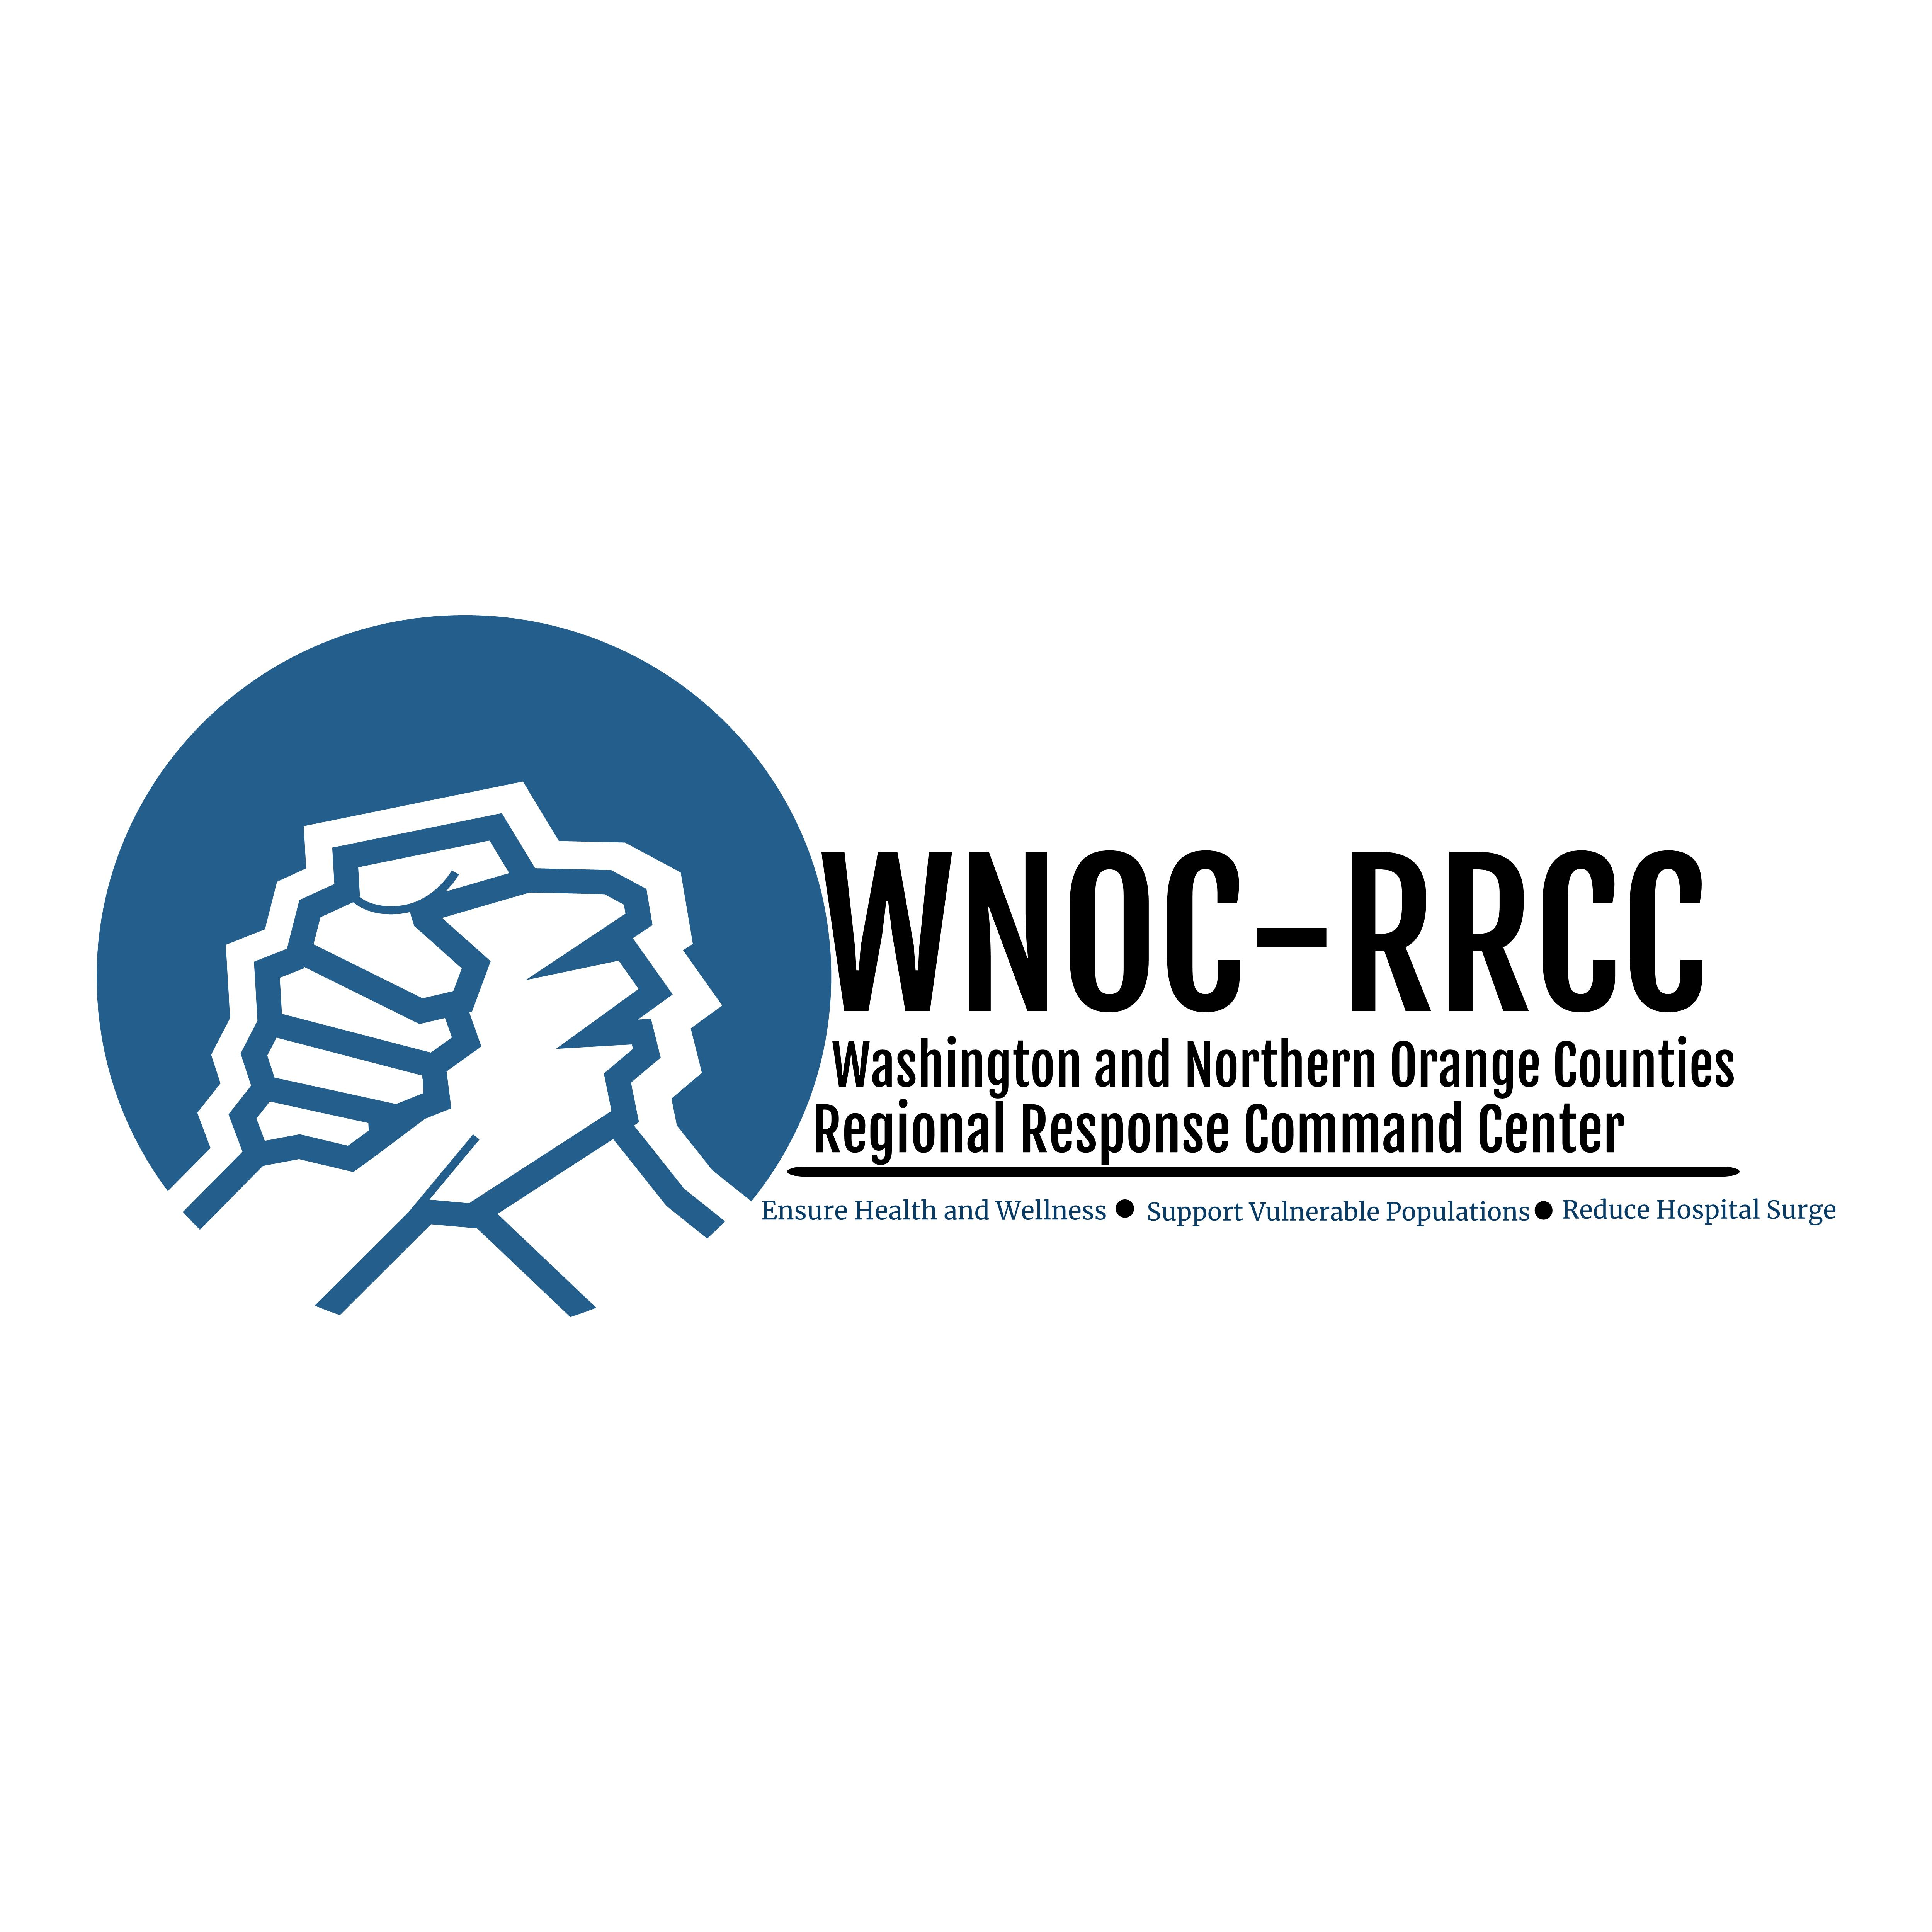

Basic Safety Guidance for Financial Transactions During COVID-19 Pandemic

April 24, 2020

The Best Way - Pay by phone or online

- Paying for goods by phone or online using your credit card Is the safest way to pay for something or to accept payment because it does not involve any physical touching of cash, credit cards, credit card terminals or receipts.

If you can’t pay by phone or online, wash your hands after contacts
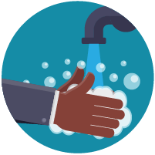
- If you must touch cash, a credit card terminal or credit card terminal stylus, or receive a receipt, wash your hands using correct technique with soap and water or hand sanitizer as soon as possible after this physical contact or exchange. Be especially careful not to touch your face, mouth or eyes before cleaning your hands.

Optional Use of Gloves

Individuals may supplement proper hand hygiene with the use of disposable gloves. Hands must be cleaned immediately before gloves are put on and immediately after they are removed. Gloves must be removed properly and discarded in trash container. Use of gloves is NOT a substitute for hand hygiene.

