Good morning,

On 3/13/25 there are 51 households who are at risk of becoming homeless and 89 households are literally homeless in Lamoille County. In total, there are 165 adults and 80 children who are at risk of or are currently experiencing literal homelessness in Lamoille County.

**Sharing Priority**

[Morristown Community Potluck](https://www.eventbrite.com/e/mfu-kick-off-community-potluck-tickets-1274005016299?aff=odcleoeventsincollection): Hosted by our town’s wellness committee and a variety of others, this monthly gathering is about sharing a meal, building relationships, and creating community

* 4/6, 5:30-7pm @ River Arts
* [Register here.](https://www.eventbrite.com/e/mfu-kick-off-community-potluck-tickets-1274005016299?aff=odcleoeventsincollection)
* First Sunday of each month, 5:30–7pm at rotating locations
  + More info: [morristownvtwellness@gmail.com](https://www.eventbrite.com/e/mfu-kick-off-community-potluck-tickets-1274005016299?aff=odcleoeventsincollection)

Substance-free event, designed to be a welcoming space for people of all experiences.

**Community**

[Human Trafficking 101 & 102 Overview](https://www.eventbrite.com/e/lamoille-human-trafficking-training-tickets-1260054740649?aff=oddtdtcreator): Who should attend: Anyone who is working with or supporting folks who could be affected by human trafficking in Vermont.

* Increase knowledge & understanding of how human trafficking is defined.
* Increase participants’ understanding of indicators & dynamics of human trafficking and exploitation.
* Increase knowledge and understanding how & when to make referrals to local services
* 4/4, 9am-4pm
* Green Mountain Tech & Career, 738 VT - 15, Hyde Park
* [RSVP](https://www.eventbrite.com/e/lamoille-human-trafficking-training-tickets-1260054740649?aff=oddtdtcreator); people can bring lunch with them and stay at the event space or there are food options nearby

[Last Legislative Breakfast](https://lamoilleeconomy.org/breakfast/): As the end of the 2025 Legislative Session approaches we want to be sure you have one last chance to speak with your local legislators as they make important decisions in Montpelier.

* 4/7, 8-9am
* Smugglers’ Notch Resort, Jeffersonville
* [Register](https://lamoilleeconomy.org/breakfast/)

[Morrisville Centennial Library April Programming](https://www.centenniallibrary.org/):

**Adult/All Age Programs**

* LRSWMD Book Group - 4/2, 5pm - Join Erika to discuss Outsmart Waste: The Modern Idea of Garbage and How to Think Our Way Out of It. Borrow a copy from the library!
* Virtual Author Talk: Jodi Picoult - 4/2, 7pm - Step into Spring with us as we chat with the highly acclaimed New York Times bestselling author Jodi Picoult about her newest novel, By Any Other Name.
* Native Bees & Pollinators with Spencer Hardy - 4/5, 10am
* Itchin to be Stichin - 4/5, 10am
* Read Aloud Sessions: Spirituality - 4/5, 12:30pm
* “Free for All” Film Screening - 4/6, 1pm (Vermont State University-Johnson campus, Bentley 207) This film tells the story of the quiet revolutionaries who created a civic institution where everything is free and the doors are open to all.
* Virtual Author Talk: Matthew Fleming - 4/8, 2pm - Join us as Smithsonian Horticulturalist Matthew Fleming, guides us through the secret world of trees as is revealed in the beautiful and absorbing guide to the giants of the plant world—The Tree Book: The Stories, Science, and History of Trees.
* “Tempest” Auditions - 4/12 & 4/13, 2pm -
* Virtual Author Talk: Greg Hurwitz - 4/24, 7pm - Gregg Hurwitz chats with us about his Orphan X series and his life as a writer of suspenseful storytelling.
* Women in Astronomy - 4/30, 5:30pm - Lamoille County Stargazers Present: Rita Ciambra's presentation on women in astronomy.

**Youth Programs**

* Author Visit: Maryanne Wood - 4/9, 3:30pm - Join local author Maryanne Wood as she reads aloud from her new children's book Randall & Hunter Go With the Flow, Two Tails on the Move.

**Just for Tweens & Teens**

* Spring Break Party - 4/18, 5pm - Kick off the break with a pizza party at the library!

**Jobs/Training**

[JCOGS Family and Youth Education Coordinator](https://www.jcogs.org/we-are-hiring.html): responsibility for the planning, teaching, and administration of JCOGS’ children’s education programs, as well as family holiday programs.

* Part-time (approx. 25 hours)
* Starts late spring, early summer
* Flexibility on hours and tasks
* Email cover letter and resume to cyndy.wyatt@jcogs.org

**Resources**

*Community Discussions: Flood Preparedness:* Learn about your town emergency plan, how to prepare for flooding, and what resources are available for flood preparedness and recovery.

* Free food and kiddo activities will be available.
* Discussion will be recorded and links to recordings will be sent out via FPF and town websites.
* Dates/Locations:
  + Cambridge/ Jeffersonville: 4/8, 6-7p at Town Office (85 Church St, Jeffersonville)
  + Wolcott: 4/9, 7-8 p at Town Office (28 Railroad St, Wolcott)
  + Johnson: 4/23, 6-7p at Town Office (293 Lower Main St, Johnson)

*Lamoille Area Recovery Network (LeARN)* is available to support flood survivors with recovery resources: learn@uwlamoille.org, 802-730-9513

[FindHelp](https://lamoille.findhelp.com/): an online database of searchable resources in Lamoille County.

[Flooding Resources](https://uwlamoille.org/learn/july-2023-flooding.html): All other resources previously sent can be found here

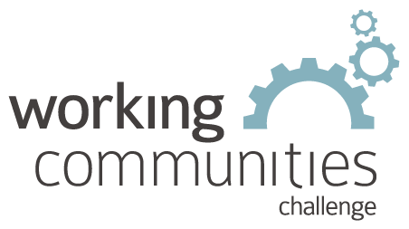 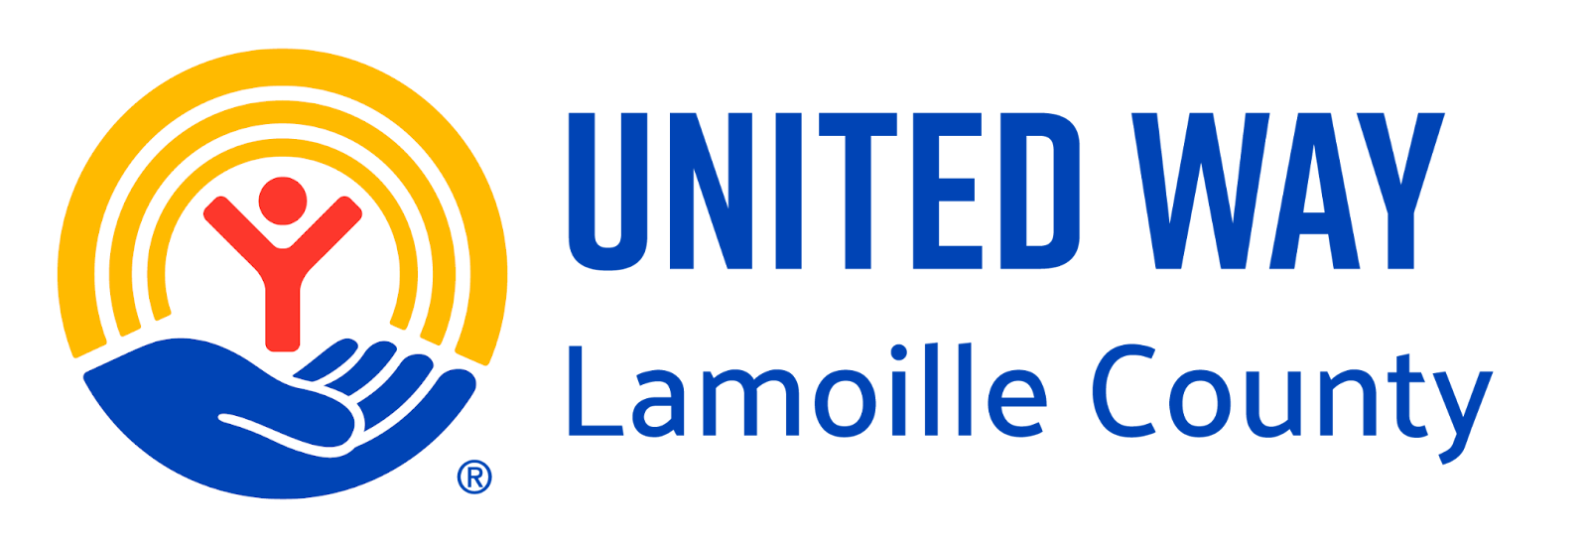

**What is WCC and what is this email?**

WCC stands for Working Communities Challenge, a three-year grant from the Federal Reserve Bank of Boston to support collaborative work to remove systemic barriers to employment. United Way of Lamoille County is the backbone partner in the [Lamoille WCC](https://uwlamoille.org/partnerships/working-communities-challenge.html), with 24 core partners participating.

Knowing what is going on helps people join the economy, so please share the sharing priority and the rest of the information in this newsletter.

* This newsletter goes out weekly to approximately 600 area leaders. The language is often exactly or close to what organizations use in order to convey what they want shared. It may not be in quotation marks for simplicity, but it is the language of the contributing organization.
* The [United Way of Lamoille County resource page](https://uwlamoille.org/get-help/) is continually updated with local and state information.

**Elisabeth Ortiz**

Working Communities Challenge

United Way Lamoille County

resources@uwlamoille.org

(802) 888-3252

110 Portland St. #1144, Morrisville, VT 05661



[www.uwlamoille.org](http://www.uwlamoille.org/) | Find us on: [Facebook](https://www.facebook.com/uwlamoille/) | [Instagram](https://www.instagram.com/uwlamoille)

__________________________________________________________________________________

Please consider the environment before printing this email.

This message and any attachments may contain confidential or privileged information, and are only for the use of the intended recipient of this message. If you are not the intended recipient, please notify the sender by return email, and delete or destroy this and all copies of this message and all attachments. Any unauthorized disclosure, use, distribution, or reproduction of this message or any attachments is prohibited and may be unlawful.