Good morning,

On 2/20/25 there are 43 households who are at risk of becoming homeless and 81 households are literally homeless in Lamoille County. In total, there are 162 adults and 79 children who are at risk of or are currently experiencing literal homelessness in Lamoille County.

**Sharing Priority**

[Act 119 Feedback](https://forms.office.com/Pages/ResponsePage.aspx?id=O5O0IK26PEOcAnDtzHVZxmrHBN5jDVVCvxvt6cx365xUMVlNQUNBUFFOMDZCMTlOUFMyQ1BJQVkySyQlQCN0PWcu) needed: We invite you to use this form to help the Vermont Agency of Human Services (AHS) learn how to better help people and communities in Vermont.

* Anyone can share feedback, whether you are part of the public, a partner, a client, or someone who works with us.
* Feedback is anonymous
* Info: [Act 119: Re-envisioning the Agency of Human Services | Agency of Human Services](https://humanservices.vermont.gov/act119)

**Community**

[Commercial Real Estate Available:](https://lamoilleeconomy.org/real-estate/)

* 213 Main Street, Hyde Park
* 330 square foot professional office or art studio
* Across the street from the courthouse and Two Sons Bakehouse Café.
* Recently renovated
* $494.00/mo includes heat, electric, water, and common area cleaning

[Legislative Breakfast:](https://lamoilleeconomy.org/breakfast/)

* 3/3, 8-9am
* Jenna’s Promise, Johnson
* $8, a light buffet style breakfast and coffee will be available upon arrival
* [Register](https://march3ledcbreakfast.eventbrite.com/)

*Rethinking Discipline for Teenagers:* Parents & Caregivers often struggle with discipline issues during the shifting dynamics of their children’s teenage years.

* Free, 2 sessions
* 3/13 & 3/20, 6-7:30 pm
* Lamoille Family Center
* [Register](https://www.lamoillefamilycenter.org/)

**Jobs/Training**

[Veteran Housing Service Coordinator Position:](https://www.uvmjobs.com/postings/77771) The Supportive Service for Veteran Families (SSVF) is a program that provides assistance to very low-income Veteran families who are experiencing homelessness and/or are at imminent risk of homelessness to gain and retain stable housing.

* Serving Northeast Kingdom Region VT
* Provide case management and housing navigation services to Veterans in northern Vermont and Clinton County, NY
* Desirable qualifications: Experiential knowledge as a military veteran and/or with homelessness; training, education, or experience with social services support desirable. Knowledge of the HUD Homeless Management Information System desired.
* [Learn more and apply here](https://www.uvmjobs.com/postings/77771)

*The Learning Earning Connection*: Check out the many careers offering On – the – Job training

opportunities

* 3/19, 9-11am
* Northeast Kingdom Learning Services Learning Center, 101 South Main St., 2 nd Floor, Hardwick
* To learn more, contact: Marina Cole, Learning Center Manager, NEKLS, marina.cole@neklsvt.org, 802-323-9627

**Resources**

[File your taxes for free](http://myfreetaxes.com): Get the assistance you need

* Mobile optimized so anyone can access MyFreeTaxes from their computer, tablet or smart phone.
* Most filers complete their taxes in less than an hour.
* MyFreeTaxes is completely free for federal and state returns.

*Lamoille Area Recovery Network (LeARN)* is available to support flood survivors with recovery resources: learn@uwlamoille.org, 802-730-9513

[FindHelp](https://lamoille.findhelp.com/): an online database of searchable resources in Lamoille County.

[Flooding Resources](https://uwlamoille.org/learn/july-2023-flooding.html): All other resources previously sent can be found here

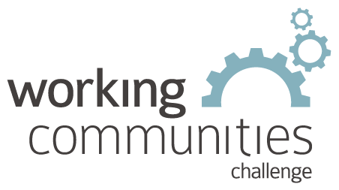 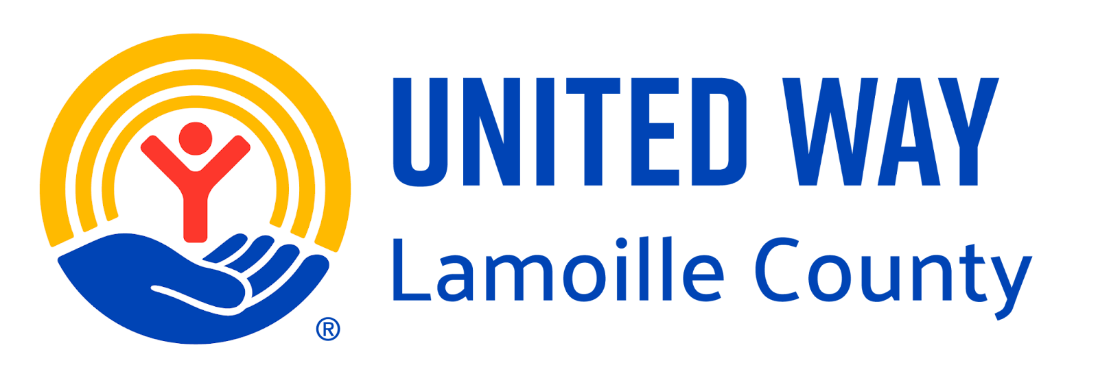

**What is WCC and what is this email?**

WCC stands for Working Communities Challenge, a three-year grant from the Federal Reserve Bank of Boston to support collaborative work to remove systemic barriers to employment. United Way of Lamoille County is the backbone partner in the [Lamoille WCC](https://uwlamoille.org/partnerships/working-communities-challenge.html), with 24 core partners participating.

Knowing what is going on helps people join the economy, so please share the sharing priority and the rest of the information in this newsletter.

* This newsletter goes out weekly to approximately 600 area leaders. The language is often exactly or close to what organizations use in order to convey what they want shared. It may not be in quotation marks for simplicity, but it is the language of the contributing organization.
* The [United Way of Lamoille County resource page](https://uwlamoille.org/get-help/) is continually updated with local and state information.

**Elisabeth Ortiz**

Working Communities Challenge

United Way Lamoille County

resources@uwlamoille.org

(802) 888-3252

110 Portland St. #1144, Morrisville, VT 05661



[www.uwlamoille.org](http://www.uwlamoille.org/) | Find us on: [Facebook](https://www.facebook.com/uwlamoille/) | [Instagram](https://www.instagram.com/uwlamoille)

__________________________________________________________________________________

Please consider the environment before printing this email.

This message and any attachments may contain confidential or privileged information, and are only for the use of the intended recipient of this message. If you are not the intended recipient, please notify the sender by return email, and delete or destroy this and all copies of this message and all attachments. Any unauthorized disclosure, use, distribution, or reproduction of this message or any attachments is prohibited and may be unlawful.