Good morning,
There are 51 adults and 19 children experiencing homelessness in our area.

Sharing Priority
The Vermont Donor Milk Center can help bridge the gap for families who cannot find formula for their infants by offering pasteurized donor human milk. They are currently waiving the requirement for a prescription for the first 40 ounces, and they have financial assistance available to help make this option as affordable as possible. No infant should go without safe nutrition and no parent should feel worried about how they will feed their infant.
- 7 days a week
- 802-276-0030, info@vtdonormilk.com, vtdonormilk.com
If you are a lactating parent, please consider whether you have milk to donate during this formula shortage. Other ways to support the Vermont Donor Milk Center.

Vaccination
Children ages 5-11 should get their booster dose five months after the second dose of their vaccines. Children can get a booster shot through their health care provider, some pharmacies, or one of the walk-in clinics listed on the state site.

Community events
Celebrity Storytellers series: Roland LaJoie reads “Bunny’s Book Club”
- TODAY 5/23, 6 PM
- Lanpher Memorial Library, Hyde Park

Alternative Takes (on Human Impact): group exhibition featuring three different perspectives: from the architecture of western civilization to the natural world, to the individuals navigating both.
- On view by appointment 5/25-10/31.
- Opening reception to meet the artists: 5/25 5-7PM
- Spruce Peak Performing Arts Center.
- Free

Dump closure due to staffing shortage: 6/5 Johnson

Book discussion: “We Contain Multitudes,” by Sarah Henstra (VT READS selection):
- 6/15, 7PM
- Jeudevine Library
- Free copies of the book: Jeudevine Library Spring Festival Book Sale

Michael Mwenso’s Ancestral Communal Listening Experience: Burlington Jazz curator will lead a series of listening experiences of Gospel, Blues, Jazz, and other Black Roots Music forms. Moderated discussions about influential artists from different generations. By Racial Equity Alliance of Lamoille (REAL) and Waterbury Area Anti-Racist Coalition (WAARC) as the first of 19 days of celebration for Juneteenth.
- 6/1, 7PM
- In-person and live stream
- Spruce Peak Performing Arts Center
- Free; pre-registration required

Housing
Housing for Vibrant Communities: Explore the connections between housing, economic development, and opportunity, including the role of municipalities in advancing housing solutions and inter-town collaboration.
- June 3
- 8AM-1PM
- At Jenna’s House in Johnson with a virtual option
For anyone who is interested in how towns and villages can create the conditions for housing development.

Addressing the Vermont Housing Challenge: Local and Regional Strategies for Success: Vermont Community Development Association (VCDA) Spring Conference.
Housing experts, community and municipal leaders, and community development professionals. Topics:
- How towns can use ARPA funds to support housing
- Investing in rehabilitation to bring older vacant housing stock back online
- Promising practices from municipalities implementing Zoning Bylaw Modernization grants
- Making sense of new resources to kickstart housing projects
Details:
- 6/28, 9:30am-4:00pm

Substance use & recovery
Annual Opioid Forum: Reigniting Community Connections
- 6/1, 6-8PM
- Green Mountain Technology and Career Center (GMTCC)
- jessica@healthylamoillevalley.org or register here

Monthly Opioid Morbidity and Mortality Report: data on opioid use and overdose

The Vermont Recovery Coach Academy: week-long, 46-hour, immersive training on Recovery Coaching in Vermont.
- 7/11-7/15, online
- Click to apply.

Self-Care and Resiliency Strategies for Recovery Coaches: the impacts of compassion fatigue and how to implement a self-care plan that works :
- 7/21, online
- Click to sign up.

Recovery Coaches in the Emergency Department Training: two-day training for Recovery Coaches working in Vermont’s Recovery Centers and their local hospitals.
- 7/27-7/28, online

Motivational Interviewing: Advancing the Practice Training: advanced training for experienced Recovery Coaches
- Summer Session: 7/11-8/29, online
- meets once a week for 7 weeks.

Job opening
AmeriCorps VISTA: United Way of Lamoille County (two positions). VISTAs will promote UWLC’s mission and vision while working on some of the most pressing issues in rural communities today: housing, poverty, mental health, and more. Upon hiring, service descriptions will be revised to fit the VISTA’s unique skill set, interests, and career goals.
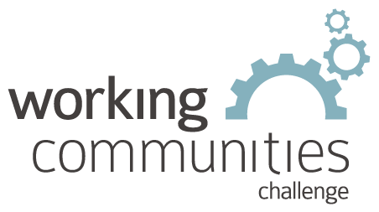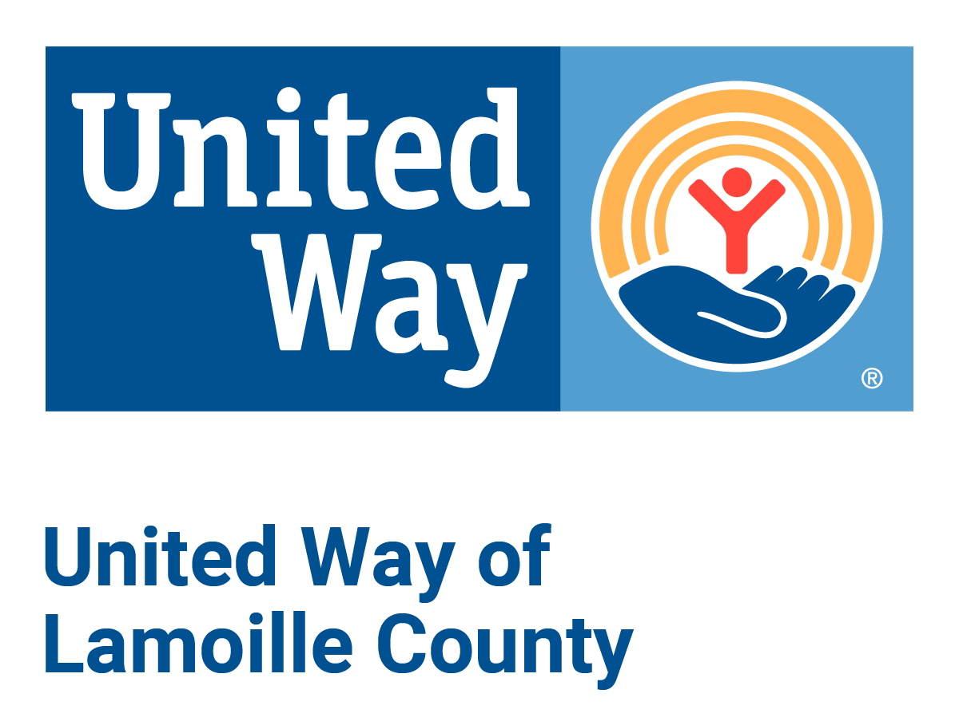

What is WCC and what is this email?
WCC stands for Working Communities Challenge, a three-year grant from the Federal Reserve Bank of Boston to support collaborative work to remove systemic barriers to employment. United Way of Lamoille County is the backbone partner in the Lamoille WCC, with 24 core partners participating.

Knowing what is going on helps people join the economy, so please share the sharing priority and the rest of the information in this newsletter.
- This newsletter goes out weekly to approximately 600 area leaders. The language is often exactly or close to what organizations use in order to convey what they want shared. It may not be in quotation marks for simplicity, but it is the language of the contributing organization.
- The United Way of Lamoille County resource page is continually updated with local and state information.

