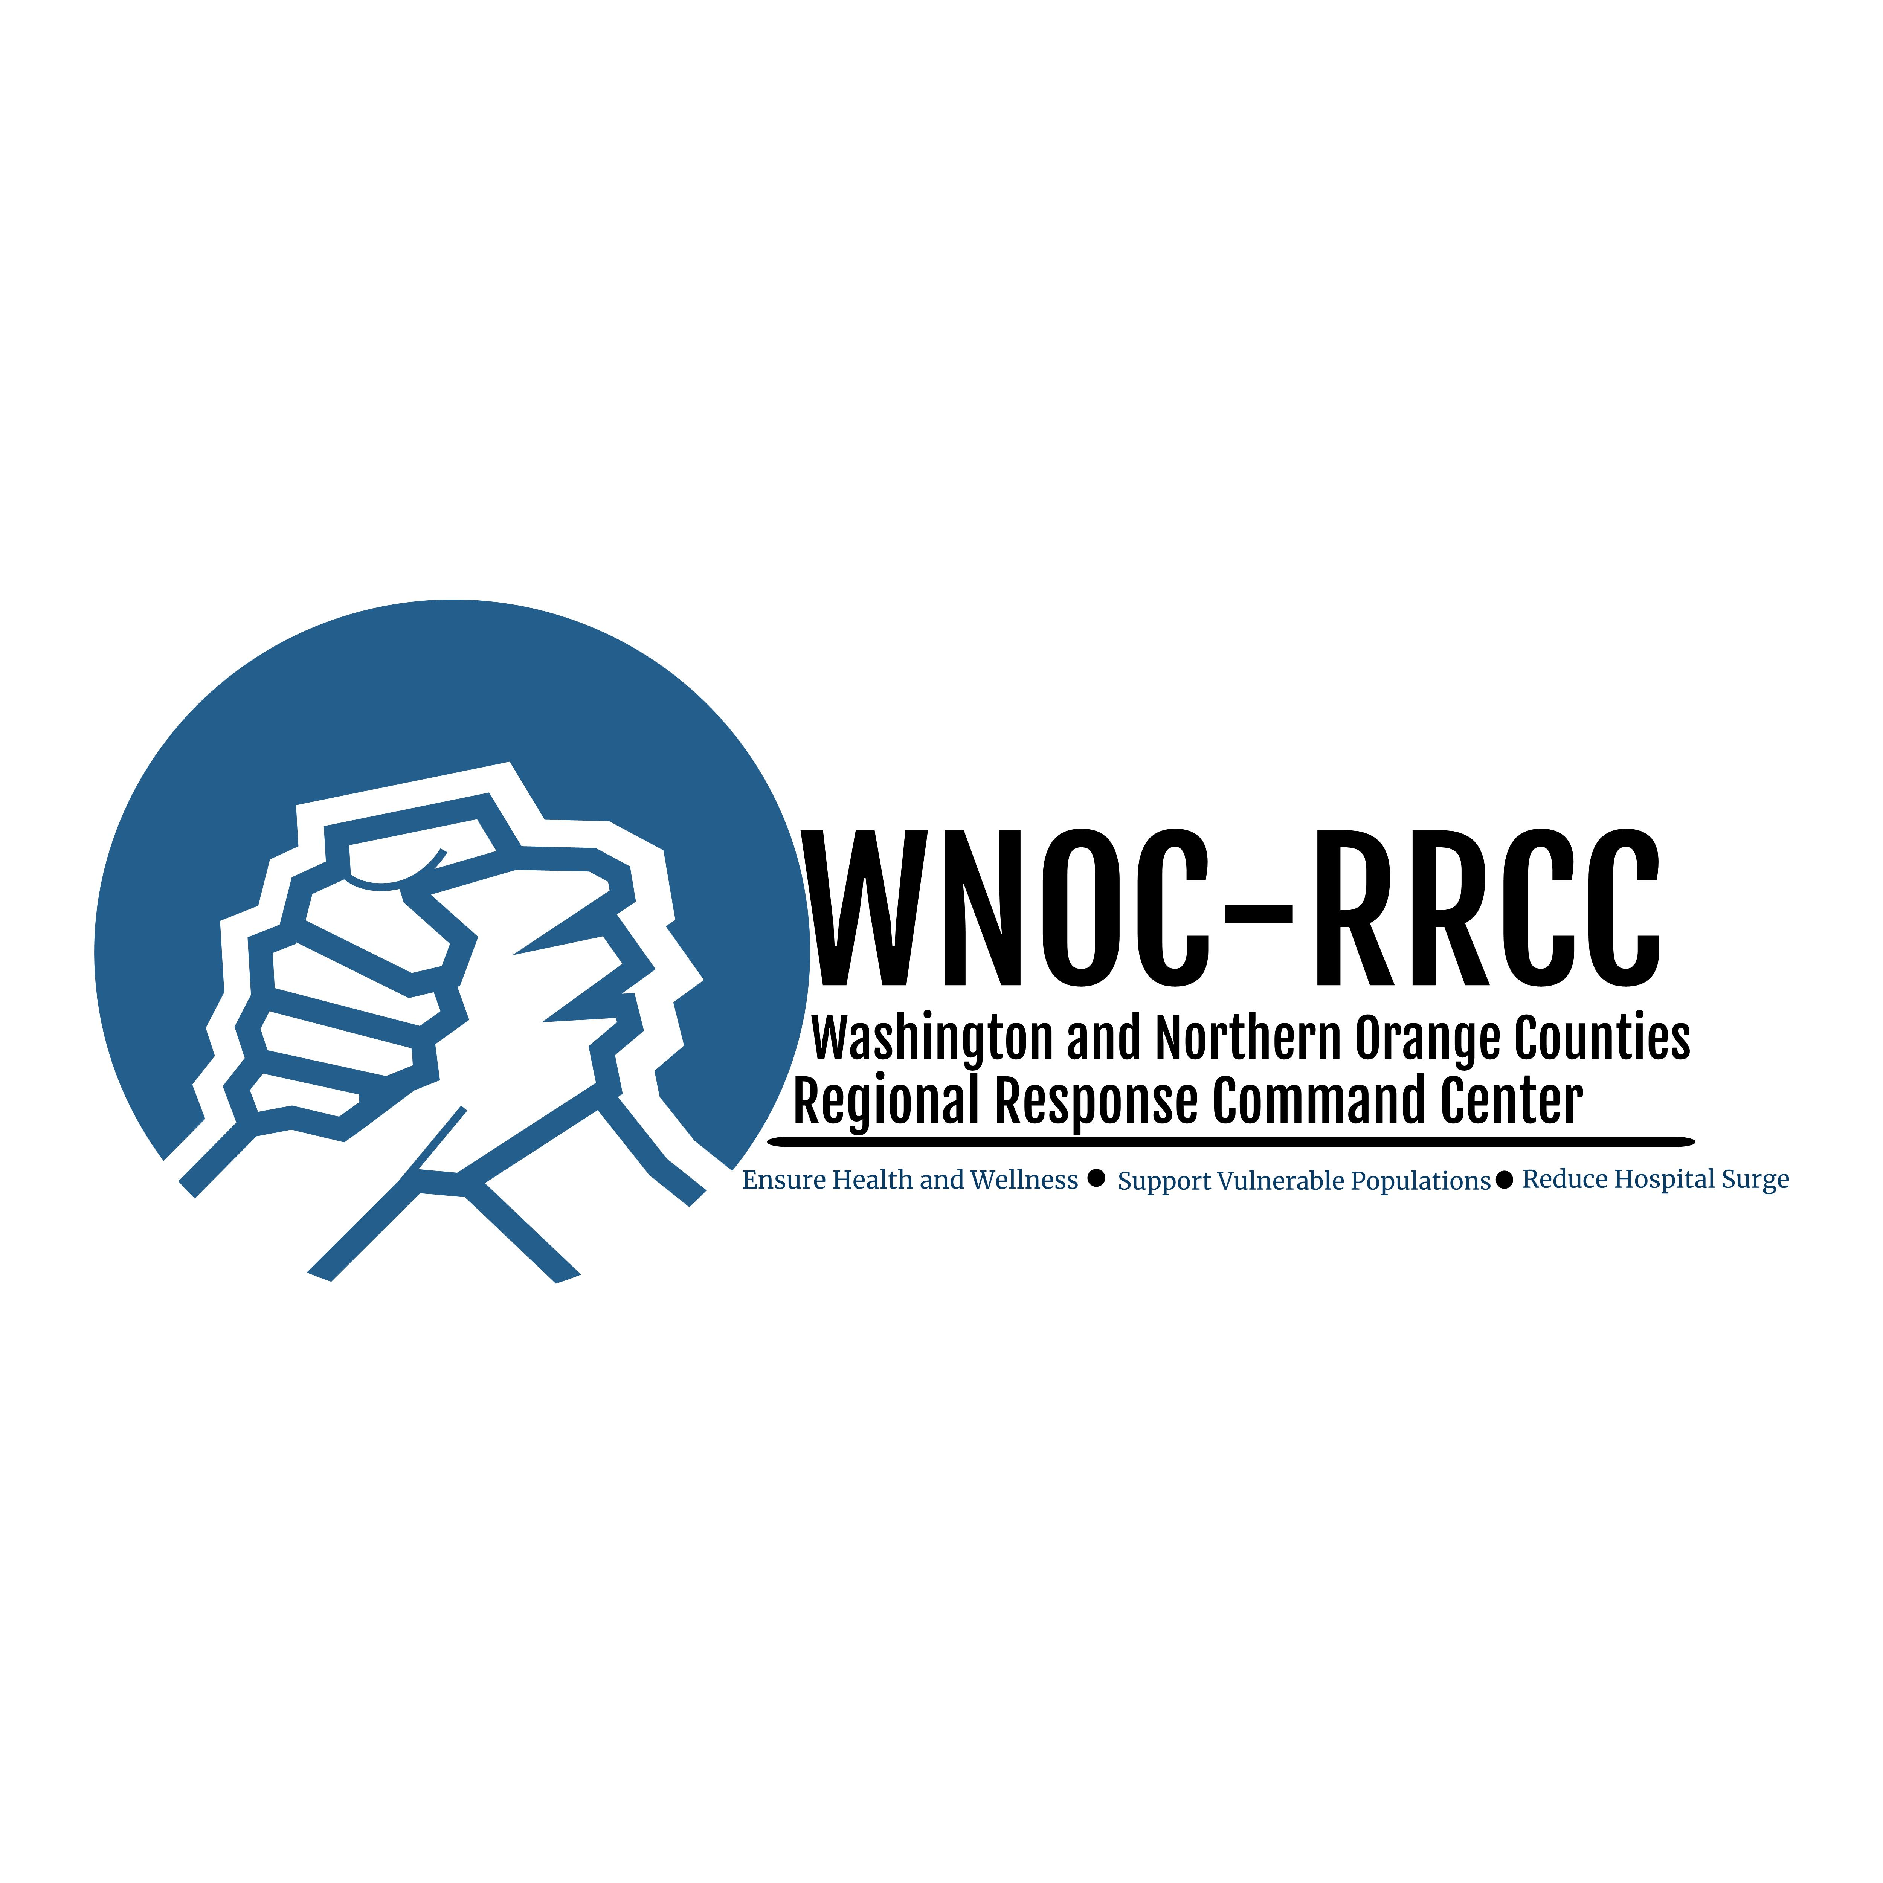

Protecting Yourself and Others
from Coronavirus Disease
April 20, 2020

Know How it Spreads
The virus spreads from person-to-person
- Between people who are in close contact with one another (within 6 feet).
- When a person coughs or sneezes.

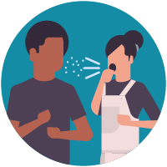

Everyone Should
Clean your hands often
- Wash your hands often with soap and water or hand sanitizer after you have been in a public place, before eating after blowing your nose, coughing, sneezing and going to the bathroom. If you don’t have access to soap and water use hand sanitizer.

- Do not touch your eyes, nose, and mouth with unwashed hands.

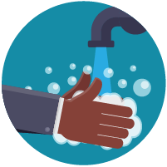

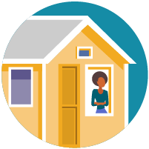
Stay away from others
- Stay at least 6 feet away from others.
- Stay in your room as much as possible.

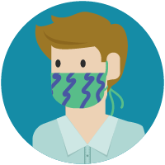
Cover your mouth and nose with a cloth face cover when around others and when you go out in public
- You could spread COVID-19 to others even if you do not feel sick.
- Wash face covering each day it is used

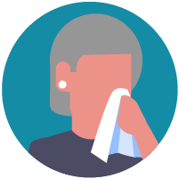
Cover coughs and sneezes
- Cover your mouth and nose with a tissue when you cough or sneeze or use the inside of your elbow.

