Good morning,
There are 151 households (185 adults and 69 children) experiencing or at risk of experiencing homelessness. 103 households are experiencing literal homelessness: general assistance program, in a tent, on street, in a vehicle, or in temporary shelter.

Sharing priority
Lamoille County Businesses: You can get guidance in supporting employees who are experiencing domestic violence or have been sexually assaulted and talking with your employees about their safety. The Clarina Howard Nichols Center offers support and training to businesses with tools to support employees who are experiencing violence. To learn more about Clarina’s services, safety planning in the workplace, and how to talk with employees about their safety, contact astyles@clarina.org.

Assistance & support
Citizens Assistance Registry for Emergencies: database for community members that may require assistance during an emergency. People who may need help during emergency restraints can register with the state so they can be identified by local responders.

Farm Share Program (NOFA-VT): reduces the cost of a local CSA (community supported agriculture) share or farm stand credit for Vermonters in need of financial assistance purchasing farm-fresh veggies, dairy products, meats, bread, and more.
- Applications close on March 31st, 2023, or when funds run out.

Helpers in Healing: family and friends monthly discussion group for people in grief after the death of a baby or a pregnancy loss.
- 2/13, 3/13, 4/10. 5/8, noon-1
- Virtual
- Register

Recovery
Recovery Day 2023
- 2/15, 9-1
- Virtual
- Featuring Congresswoman Becca Balint
- Art submissions welcome

Peer recovery coaches needed: help support peers in recovery
- Paid training and certification, paid position
- Flexible schedule
- Contact: ken.wetherell@ncvrc.com 802-851-8120

Healthy communities
RSVP and Meals on Wheels of Lamoille County (MOWLC) need volunteers to deliver Meals on Wheels on a weekday morning or who can substitute for other drivers.
- Reimburses for mileage and provides lunch
- agreshin@cvcoa.org or 802-241-4840.

Vermont Healthy Communities: technical assistance pilot for community-led design, placemaking, and healthy equity projects across Vermont
- from safer, walkable, universally accessible streets to more green spaces
- Applications now open.

Health Equity Ambassador: seeking trusted community members to support and co-lead on navigating community issues and opportunities, engage community members, develop community ideas and action plans to advance health equity in their community, and receive training and compensation for their time.

Webinars on cybersecurity: 1PM
- Cyber Insurance: Understand how to meet insurance requirements and address compliance concerns. 2/9
- Risk Management: Learn about the most effective actions you can take to protect your business from cyberattacks. 2/16
- The 2023 Threat Landscape: Gain insight from our team of experts on current security risks and common tactics cybercriminals use today. 2/23

Job opportunities
Public Health Nutritionist III: seeking an experienced, well-organized, and detail-oriented Nutritionist with great listening and communication skills to work at out of the Department of Health Morrisville District Office.

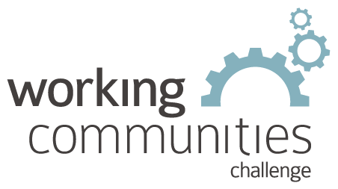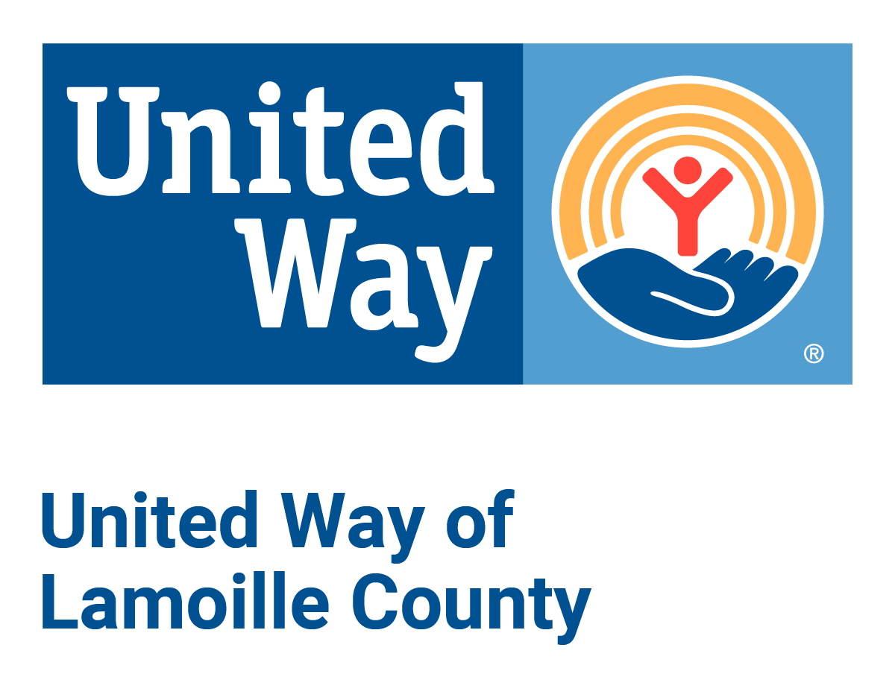

What is WCC and what is this email?
WCC stands for Working Communities Challenge, a three-year grant from the Federal Reserve Bank of Boston to support collaborative work to remove systemic barriers to employment. United Way of Lamoille County is the backbone partner in the Lamoille WCC, with 24 core partners participating.

Knowing what is going on helps people join the economy, so please share the sharing priority and the rest of the information in this newsletter.
- This newsletter goes out weekly to approximately 600 area leaders. The language is often exactly or close to what organizations use in order to convey what they want shared. It may not be in quotation marks for simplicity, but it is the language of the contributing organization.
- The United Way of Lamoille County resource page is continually updated with local and state information.

