Good morning,

On 6/18/25 there are 36 households who are at risk of becoming homeless and 48 households are literally homeless in Lamoille County. In total, there are 128 adults and 48 children who are at risk of or are currently experiencing literal homelessness in Lamoille County.

**Sharing Priority**

[Free Small Business Webinars:](https://sblc.vermontlaw.edu/) Vermont Small Business Law Center has provides technical legal assistance for small businesses, as well as educational services on what small businesses, including legal topics involved in capital transactions (such as business entities, contracts, lending, and financing).

* 7/2, 4pm – 6pm: [Business Contracts: Basics and In Practice](https://us06web.zoom.us/meeting/register/P0J9WSe2S5iBoMq8IZMYmw)
* 7/22, 4pm – 6pm: [Lending & Financing for Small Businesses](https://us06web.zoom.us/meeting/register/ZiWtd9c8SJ2DRGEai8GWSQ)

**Community**

Cooling Center Map: [Hot Weather | Vermont Department of Health](https://www.healthvermont.gov/environment/climate-health/hot-weather)

*Stowe Transfer Station update*: Over the next two weeks, we will be having the lower yard paved. During the construction:

* we will be unable to accept tires or items with refrigerant
* the station will be CLOSED to the public on June 25th & June 26th; These dates are subject tot change pending weather.
* Our other transfer stations will be open normal operating hours. [Click here](https://lrswmd.us9.list-manage.com/track/click?u=84b45de1d00679873f72793ee&id=ef4c756dc7&e=d99ee69f63) for info on accepted materials at each location.

*LRSWMD Waste Warrior Volunteers needed*: help educate community members across our 12 districts

* Attend special events such as farmers’ markets to answer questions
* Create social media or newsletter content
* Co-teach workshops on waste reduction, recycling, and composting programs
* Sign up: [outreach@lrswmd.org](mailto:outreach@lrswmd.org), 802-888-7317 x3

**Resources**

*Lamoille Area Recovery Network (LeARN)* is available to support flood survivors with recovery resources: learn@uwlamoille.org, 802-730-9513

[Flooding Resources](https://uwlamoille.org/learn/july-2023-flooding.html): All other resources previously sent can be found here

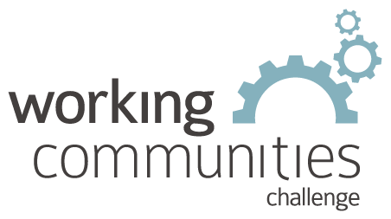 

**What is WCC and what is this email?**

WCC stands for Working Communities Challenge, a three-year grant from the Federal Reserve Bank of Boston to support collaborative work to remove systemic barriers to employment. United Way of Lamoille County is the backbone partner in the [Lamoille WCC](https://uwlamoille.org/partnerships/working-communities-challenge.html), with 24 core partners participating.

Knowing what is going on helps people join the economy, so please share the sharing priority and the rest of the information in this newsletter.

* This newsletter goes out weekly to approximately 600 area leaders. The language is often exactly or close to what organizations use in order to convey what they want shared. It may not be in quotation marks for simplicity, but it is the language of the contributing organization.
* The [United Way of Lamoille County resource page](https://uwlamoille.org/get-help/) is continually updated with local and state information.

**Elisabeth Ortiz**

Working Communities Challenge

United Way Lamoille County

resources@uwlamoille.org

(802) 888-3252

110 Portland St. #1144, Morrisville, VT 05661



[www.uwlamoille.org](http://www.uwlamoille.org/) | Find us on: [Facebook](https://www.facebook.com/uwlamoille/) | [Instagram](https://www.instagram.com/uwlamoille)

__________________________________________________________________________________

Please consider the environment before printing this email.

This message and any attachments may contain confidential or privileged information, and are only for the use of the intended recipient of this message. If you are not the intended recipient, please notify the sender by return email, and delete or destroy this and all copies of this message and all attachments. Any unauthorized disclosure, use, distribution, or reproduction of this message or any attachments is prohibited and may be unlawful.