Good morning,

On 8/1/25 there are 52 households who are at risk of becoming homeless and 67 households are literally homeless in Lamoille County. In total, there are 164 adults and 83 children who are at risk of or are currently experiencing literal homelessness in Lamoille County.

**Sharing Priority**

[Parent/Caregiver Survey: Adolescent Sexual and Reproductive Health](https://s.alchemer.com/s3/Sexual-and-Reproductive-Health-Assessment): Short, online survey from VT Dept of Health to better support adolescents and families across the state when it comes to sexual and reproductive health.

* We want to understand how families are navigating topics like puberty, relationships, consent, contraception, and health care access.
* This feedback will help shape future resources, programs, and public health efforts that support Vermont youth and their families.
* Participants can be entered for the chance to win one $100 gift card or one of two $50 gift cards

**Community**

2nd edition of the [Healthy Lamoille Valley Coaches Handbook](https://www.healthylamoillevalley.org/coaches-handbook/) - builds on the first edition designed for elementary age youth sports and expands to support those working with middle and high school athletes with topics including:

* standard pregame sportsmanship & inclusion statement
* equity in youth sports and building a culture of respect
* coaches as protective factors and the science behind risk and protective factors
* parent and athlete communication support
* the “Huddle Up” Program for team check-ins and connection
* tools for reflection, accountability, and planning

[CPEP registration open](https://ccv.edu/workforce-career-development/career-pathway-entry-program-cpep/): CPEP at CCV helps participants gain access to high-paying careers in

manufacturing, healthcare, and human services

* One free 6 week, 3 credit, hybrid course through CCV, choosing from:
  + Introduction to Healthcare
  + Introduction to Human Services
  + Principles of Manufacturing
* A $560 stipend based on class attendance
* Job shadow experiences with Vermont employers
* [Register](https://ccv.edu/workforce-career-development/career-pathway-entry-program-cpep/)

**Money Management**

*Slice Into Savings* - Capstone’s Weatherization team will be hosting a free in-person event to help people complete their weatherization application.

* 8/28, 3-6pm
* 250 Industrial Park Drive, Morrisville
* Enjoy a slice of pizza and bottle of water when you participate!

[Money Moves](http://capstonevt.org/workshops) - Free and informative online workshop with Capstone's financial coach, Rosie Gray for anyone looking to learn more about money management

* Wednesdays starting 9/17
* 12-1:30pm over Zoom
* [Register](http://capstonevt.org/workshops)

[Business Startup Basics](http://capstonevt.org/workshops) – A free six-week online series of classes to help you build a foundation for your small or micro-business

* Wednesdays starting 9/17
* 9-11am over Zoom
* [Register](http://capstonevt.org/workshops)

**Resources**

[Lamoille.Findhelp.com](http://lamoille.findhelp.com) - local resources in our area

*Lamoille Area Recovery Network (LeARN)* is available to support flood survivors with recovery resources: learn@uwlamoille.org, 802-730-9513

[Flooding Resources](https://uwlamoille.org/learn/july-2023-flooding.html): All other resources previously sent can be found here

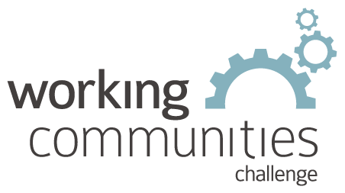 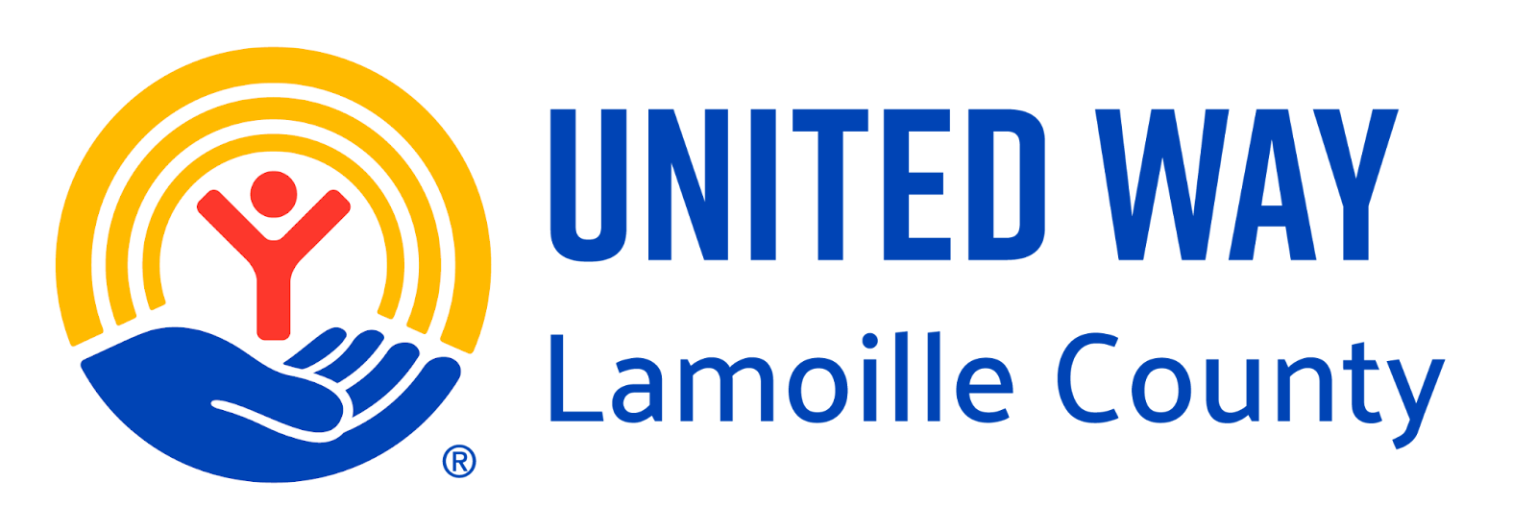

**What is WCC and what is this email?**

WCC stands for Working Communities Challenge, a three-year grant from the Federal Reserve Bank of Boston to support collaborative work to remove systemic barriers to employment. United Way of Lamoille County is the backbone partner in the [Lamoille WCC](https://uwlamoille.org/partnerships/working-communities-challenge.html), with 24 core partners participating.

Knowing what is going on helps people join the economy, so please share the sharing priority and the rest of the information in this newsletter.

* This newsletter goes out weekly to approximately 600 area leaders. The language is often exactly or close to what organizations use in order to convey what they want shared. It may not be in quotation marks for simplicity, but it is the language of the contributing organization.
* The [United Way of Lamoille County resource page](https://uwlamoille.org/get-help/) is continually updated with local and state information.

**Elisabeth Ortiz**

Working Communities Challenge

United Way Lamoille County

resources@uwlamoille.org

(802) 888-3252

110 Portland St. #1144, Morrisville, VT 05661



[www.uwlamoille.org](http://www.uwlamoille.org/) | Find us on: [Facebook](https://www.facebook.com/uwlamoille/) | [Instagram](https://www.instagram.com/uwlamoille)

__________________________________________________________________________________

Please consider the environment before printing this email.

This message and any attachments may contain confidential or privileged information, and are only for the use of the intended recipient of this message. If you are not the intended recipient, please notify the sender by return email, and delete or destroy this and all copies of this message and all attachments. Any unauthorized disclosure, use, distribution, or reproduction of this message or any attachments is prohibited and may be unlawful.