Good morning,

On 4/17/25 there are 44 households who are at risk of becoming homeless and 68 households are literally homeless in Lamoille County. In total, there are 145 adults and 57 children who are at risk of or are currently experiencing literal homelessness in Lamoille County.

**Sharing Priority**

[Green Up Day 2025](https://www.surveymonkey.com/r/hlv-cleanup-2025) – May 3rd: If you're planning a Green Up Day activity, let HLV know. Your participation helps us collect valuable data on substance use impact in our region. Please complete the survey after your Green Up Day activity.

**Community**

*CORRECTED TIME: Spring Break nature based playgroup:* for families with kids ages 0-12

* seasonally-appropriate loose parts, science tools, a mud kitchen and giveaways to help nurture a sense of wonder, place, and well-being
* 4/24, drop in any time between 10am-12pm
* Pizza lunch to follow
* Lamoille Family Center, 480 Cady’s Falls Rd, Morrisville

[May Programs at the Morristown Centennial Library](https://www.centenniallibrary.org/)

**Youth Programs**

* STEM Workshops - Thursdays thru 5/22, 3:30pm

**Just for Tweens and Teens**

* Babysitting Class - Wednesdays in May, 5pm - Learn the basics of babysitting. Sign-up required.

**Adult/All Ages Programs**

* Friends of the Morristown Centennial Library Meeting - 5/1, 4pm - Get involved with special library events & promoting literacy in our town!
* Cirque de Fuego - Friday 5/2, 8pm - An awesome show of fire dancing for all ages on the library’s front lawn. Weather dependent so check our FB for updates.
* Itchin’ to be Stitchin’ - 5/3, 10am
* Sorting the News from the Chaff - 5/3, 2pm - Veteran journalist and educator Mark Timney will share strategies for evaluating news sources in the rapidly changing digital information age.
* LRSWMD Book Group - 5/7, 5pm - Join Erika to discuss The Story of Stuff by Annie Leonard. Borrow a copy from the library!
* Virtual Author Talk: David Rosmarin - 5/7, 2pm - In this enlightening online webinar, you will learn how to use anxiety to become more self-accepting, connected to others, and resilient.
* Virtual Author Talk: Liann Zhang - 5/14, 7pm - Join us for an propulsive online conversation with author Liann Zhang as she chats with us about her debut thriller Julie Chan is Dead.
* Virtual Author Talk: Rachelle Bergstein - 5/21, 2pm - Join the author as she takes an expansive look at Judy Blume’s life, work, and cultural impact, focusing on her most iconic—and controversial—young adult novels.

**Parent Workshops**

[Navigating: Special Education for Your Child](https://www.lamoillefamilycenter.org/) - Free workshop

* Learn more about the Individualized Education Plan (IEP) process, parent’s rights, and tips for communicating more effectively with your child’s team?
* 4/29, 6-7:30pm over Zoom
* [Register](https://www.lamoillefamilycenter.org/)

[Joyful Connections with Kids and Teens:](https://www.eventbrite.com/e/joyful-connections-with-kids-teens-tickets-1264837806929?aff=ebdsoporgprofile) This interactive workshop welcomes parents, grandparents, and anyone with youth in their lives. Come discover new ways to transform everyday moments into opportunities for connection and joy.

* 4/29, 5:30 – 6:30pm
* Morristown Centennial Library  
  [Register Here](https://www.eventbrite.com/e/joyful-connections-with-kids-teens-tickets-1264837806929?aff=ebdsoporgprofile)
* Each participant will receive a free family game to take home

**Resources**

*Lamoille Area Recovery Network (LeARN)* is available to support flood survivors with recovery resources: learn@uwlamoille.org, 802-730-9513

[FindHelp](https://lamoille.findhelp.com/): an online database of searchable resources in Lamoille County.

[Flooding Resources](https://uwlamoille.org/learn/july-2023-flooding.html): All other resources previously sent can be found here

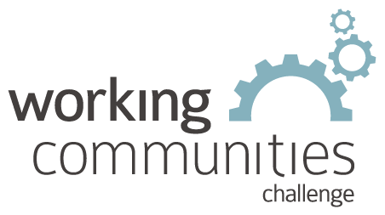 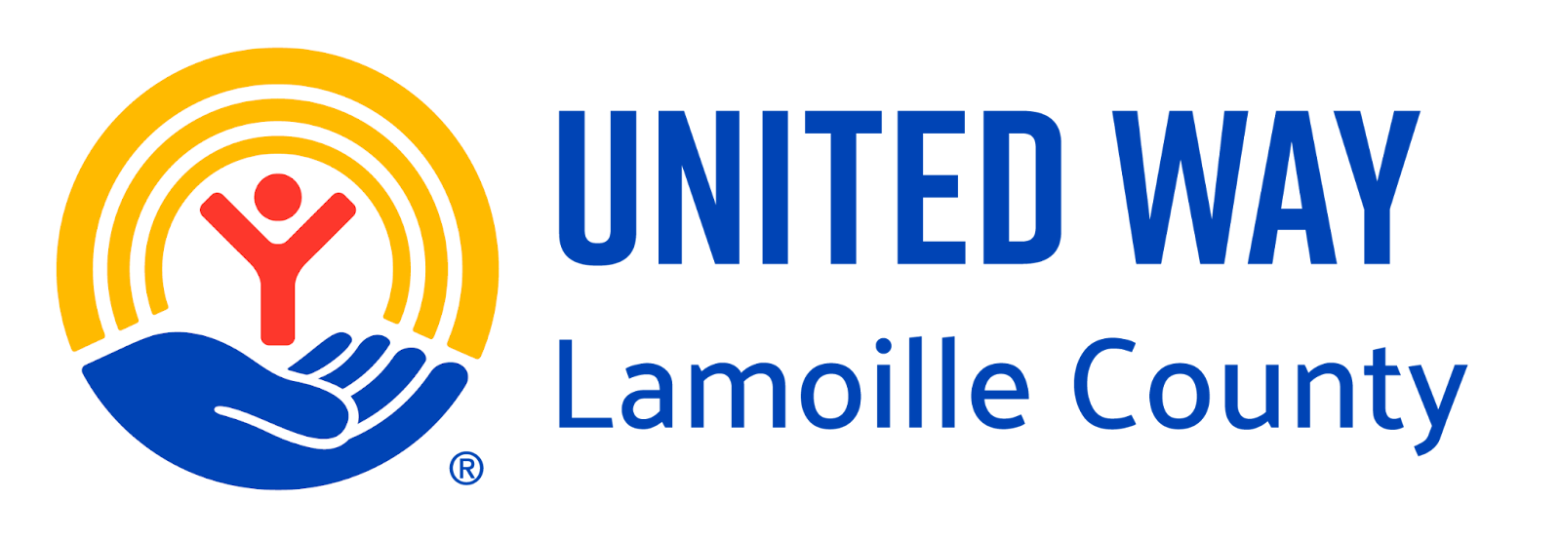

**What is WCC and what is this email?**

WCC stands for Working Communities Challenge, a three-year grant from the Federal Reserve Bank of Boston to support collaborative work to remove systemic barriers to employment. United Way of Lamoille County is the backbone partner in the [Lamoille WCC](https://uwlamoille.org/partnerships/working-communities-challenge.html), with 24 core partners participating.

Knowing what is going on helps people join the economy, so please share the sharing priority and the rest of the information in this newsletter.

* This newsletter goes out weekly to approximately 600 area leaders. The language is often exactly or close to what organizations use in order to convey what they want shared. It may not be in quotation marks for simplicity, but it is the language of the contributing organization.
* The [United Way of Lamoille County resource page](https://uwlamoille.org/get-help/) is continually updated with local and state information.

**Elisabeth Ortiz**

Working Communities Challenge

United Way Lamoille County

resources@uwlamoille.org

(802) 888-3252

110 Portland St. #1144, Morrisville, VT 05661



[www.uwlamoille.org](http://www.uwlamoille.org/) | Find us on: [Facebook](https://www.facebook.com/uwlamoille/) | [Instagram](https://www.instagram.com/uwlamoille)

__________________________________________________________________________________

Please consider the environment before printing this email.

This message and any attachments may contain confidential or privileged information, and are only for the use of the intended recipient of this message. If you are not the intended recipient, please notify the sender by return email, and delete or destroy this and all copies of this message and all attachments. Any unauthorized disclosure, use, distribution, or reproduction of this message or any attachments is prohibited and may be unlawful.