**Please note there will be no newsletter Monday, September 2nd**

Good morning,

On 8/20/24 there are 80 households who are at risk of becoming homeless and 76 households are literally homeless in Lamoille County. In total, there are 199 adults and 95 children who are at risk of or are currently experiencing literal homelessness in Lamoille County.

**Sharing Priority**

[*SBA Disaster Loans Available for Flood-Impacted Businesses*](https://lending.sba.gov/)*:* available to assist individuals and communities in recovering from flooding that occurred from July 9 -11th.

* Applications may be submitted online using [MySBA Loan Portal](https://lending.sba.gov/) or other locally announced locations.
* Questions: [disastercustomerservice@sba.gov](mailto:disastercustomerservice@sba.gov) or 1-800-659-2955
* Does not include damage to private and public property caused by storms on July 30.
* [Physical Damage Loans](https://mbo6segab.cc.rs6.net/tn.jsp?f=001kSjJk6Wp3yk-3udnxl0sVUJ1HYclmsd7tYpsiNI89zzY5WKyRqnvrLJZvDIUJZPwjuUH0-5UHlm3hfsP7sG-4XF3KzNwFMpG0THwm_xdWXivFi6ubXscdsvGa0vb-kgj-pqpG6zfNONLEvrHcaric49cwHcbFgJEriVABbbO8H5QW788CNeGg5eRHF7b0S3zL9Lj8dPQbMuFMwJKfJFrBrr1MI56HwSkjR5rpTmmpho=&c=1GYchWlz30XtfdT5kz6Z8VFbWWfrHwG699EvNFgV8D-MkH1gMu5m7g==&ch=v_frbPqFO9sio4vOPIQB3IYuzzq9zHhKn2sMoYOsVGLjrhk5E38xXg==) - Eligible Counties: Addison, Caledonia, Chittenden, Essex, Lamoille, Orleans, Washington
  + Deadline: 10/21/24
* [Economic Injury Loans](https://mbo6segab.cc.rs6.net/tn.jsp?f=001kSjJk6Wp3yk-3udnxl0sVUJ1HYclmsd7tYpsiNI89zzY5WKyRqnvrLJZvDIUJZPwwkBS0ypKHJOcXTjBGwdyolg5hMSZ-yakWMv0QTpSpSAXiQyI5DOq1XE8DuGouUC1Kk203z4BVM40IWZ-SU-wKmHJ3FtCwrwL-JRQClIp8AzCVdJjm9q9r70en4PeiZplIT_012FkT9iV0jUU2ifEFFgRKVdhwW0L_EiI_LSGo8yXGTIFnYvKHQ==&c=1GYchWlz30XtfdT5kz6Z8VFbWWfrHwG699EvNFgV8D-MkH1gMu5m7g==&ch=v_frbPqFO9sio4vOPIQB3IYuzzq9zHhKn2sMoYOsVGLjrhk5E38xXg==) - Eligible Counties: Addison, Caledonia, Chittenden, Essex, Franklin, Grand Isle, Lamoille, Orange, Orleans, Rutland, Washington, Windsor
  + Deadline: 5/20/25

**Community**

[LRSWMD communication survey](https://lrswmd.us9.list-manage.com/track/click?u=84b45de1d00679873f72793ee&id=2204d43e4d&e=d99ee69f63): LRSWMD is collecting information on district residents’ communication preferences on facility updates and outreach programming.

* [Survey](https://lrswmd.us9.list-manage.com/track/click?u=84b45de1d00679873f72793ee&id=2204d43e4d&e=d99ee69f63) - brief and chance to win a small prize

[Pointing to Hope; Resilience, Coping and Caring for Community](https://us02web.zoom.us/meeting/register/tZcpf--rpjovGddzo5veCwcglj3aD8mQmSE_#/registration): Amy Carol Dominguez, Director of Disaster Services at Vibrant Emotional Health will lead a workshop to touch on a few important tools and perspectives on community mental health, and well-being following layered disasters, as we have experienced in Vermont in recent years.

* 9/4, 10-11:30am, online
* [Register](https://us02web.zoom.us/meeting/register/tZcpf--rpjovGddzo5veCwcglj3aD8mQmSE_)

[Morrisville Centennial Library September programs:](https://www.centenniallibrary.org/)

**Adult/All Ages Programs**

* Virtual Author Talk: Garrett Graff - 9/10, 2pm - An expert at capturing the human drama, Graff will speak about his body of work with particular focus on his oral histories, The Only Plane in the Sky: An Oral History of 9/11 and When the Sea Came Alive: An Oral History of D-Day.
* Peer Growth & Lifelong Learning - Wednesdays starting 9/18, 1pm - A continuing education course for adults with intellectual disabilities in Lamoille County
* Virtual Author Talk: Nate Klemp - 9/18, 2pm - Join us as New York Times bestselling author and philosopher Nate Klemp helps us explore pathways back to openminded living.

**Just for Tweens & Teens**

* Teen Time - Wednesdays, 3:30pm
* Dungeons & Dragons - Thursdays, 3:30pm
* Tween Scene - Fridays, 3:30pm
* L.I.F.T. (LGBTQIA+) - 9/25, 3:30pm

**Youth Programs**

* Preschool Story Time - Tuesdays, 10:30am
* Crafternoon - Tuesdays starting 9/10, 3:30pm - ages 6+
* LEGO Challenge - 9/12, 9/19 & 9/26, 3:30pm
* Touch a Truck - 9/14, 10am
* Saturday Storytime - Saturdays, 11am

**Flooding Resources**

*Lamoille Area Recovery Network (LeARN)* is available to support flood survivors with recovery resources: learn@uwlamoille.org, 802-730-9513

[FindHelp](https://lamoille.findhelp.com/): an online database of searchable resources in Lamoille County.

[Flooding Resources](https://uwlamoille.org/learn/july-2023-flooding.html): All other resources previously sent can be found here

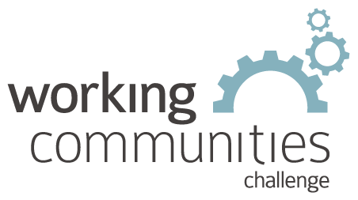 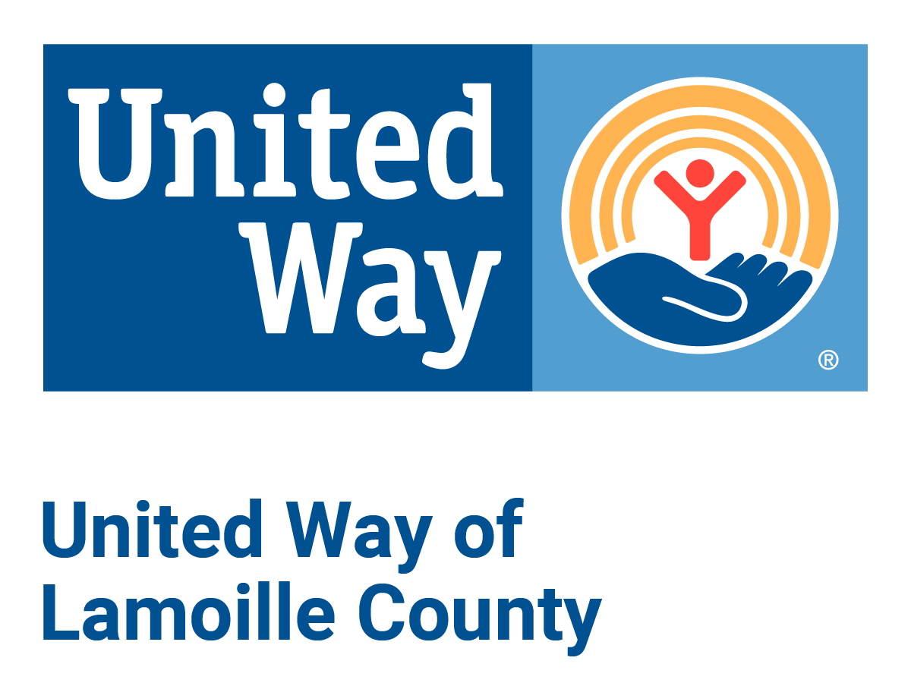

**What is WCC and what is this email?**

WCC stands for Working Communities Challenge, a three-year grant from the Federal Reserve Bank of Boston to support collaborative work to remove systemic barriers to employment. United Way of Lamoille County is the backbone partner in the [Lamoille WCC](https://uwlamoille.org/partnerships/working-communities-challenge.html), with 24 core partners participating.

Knowing what is going on helps people join the economy, so please share the sharing priority and the rest of the information in this newsletter.

* This newsletter goes out weekly to approximately 600 area leaders. The language is often exactly or close to what organizations use in order to convey what they want shared. It may not be in quotation marks for simplicity, but it is the language of the contributing organization.
* The [United Way of Lamoille County resource page](https://uwlamoille.org/get-help/) is continually updated with local and state information.

Elisabeth Ortiz

Working Communities Challenge

United Way of Lamoille County