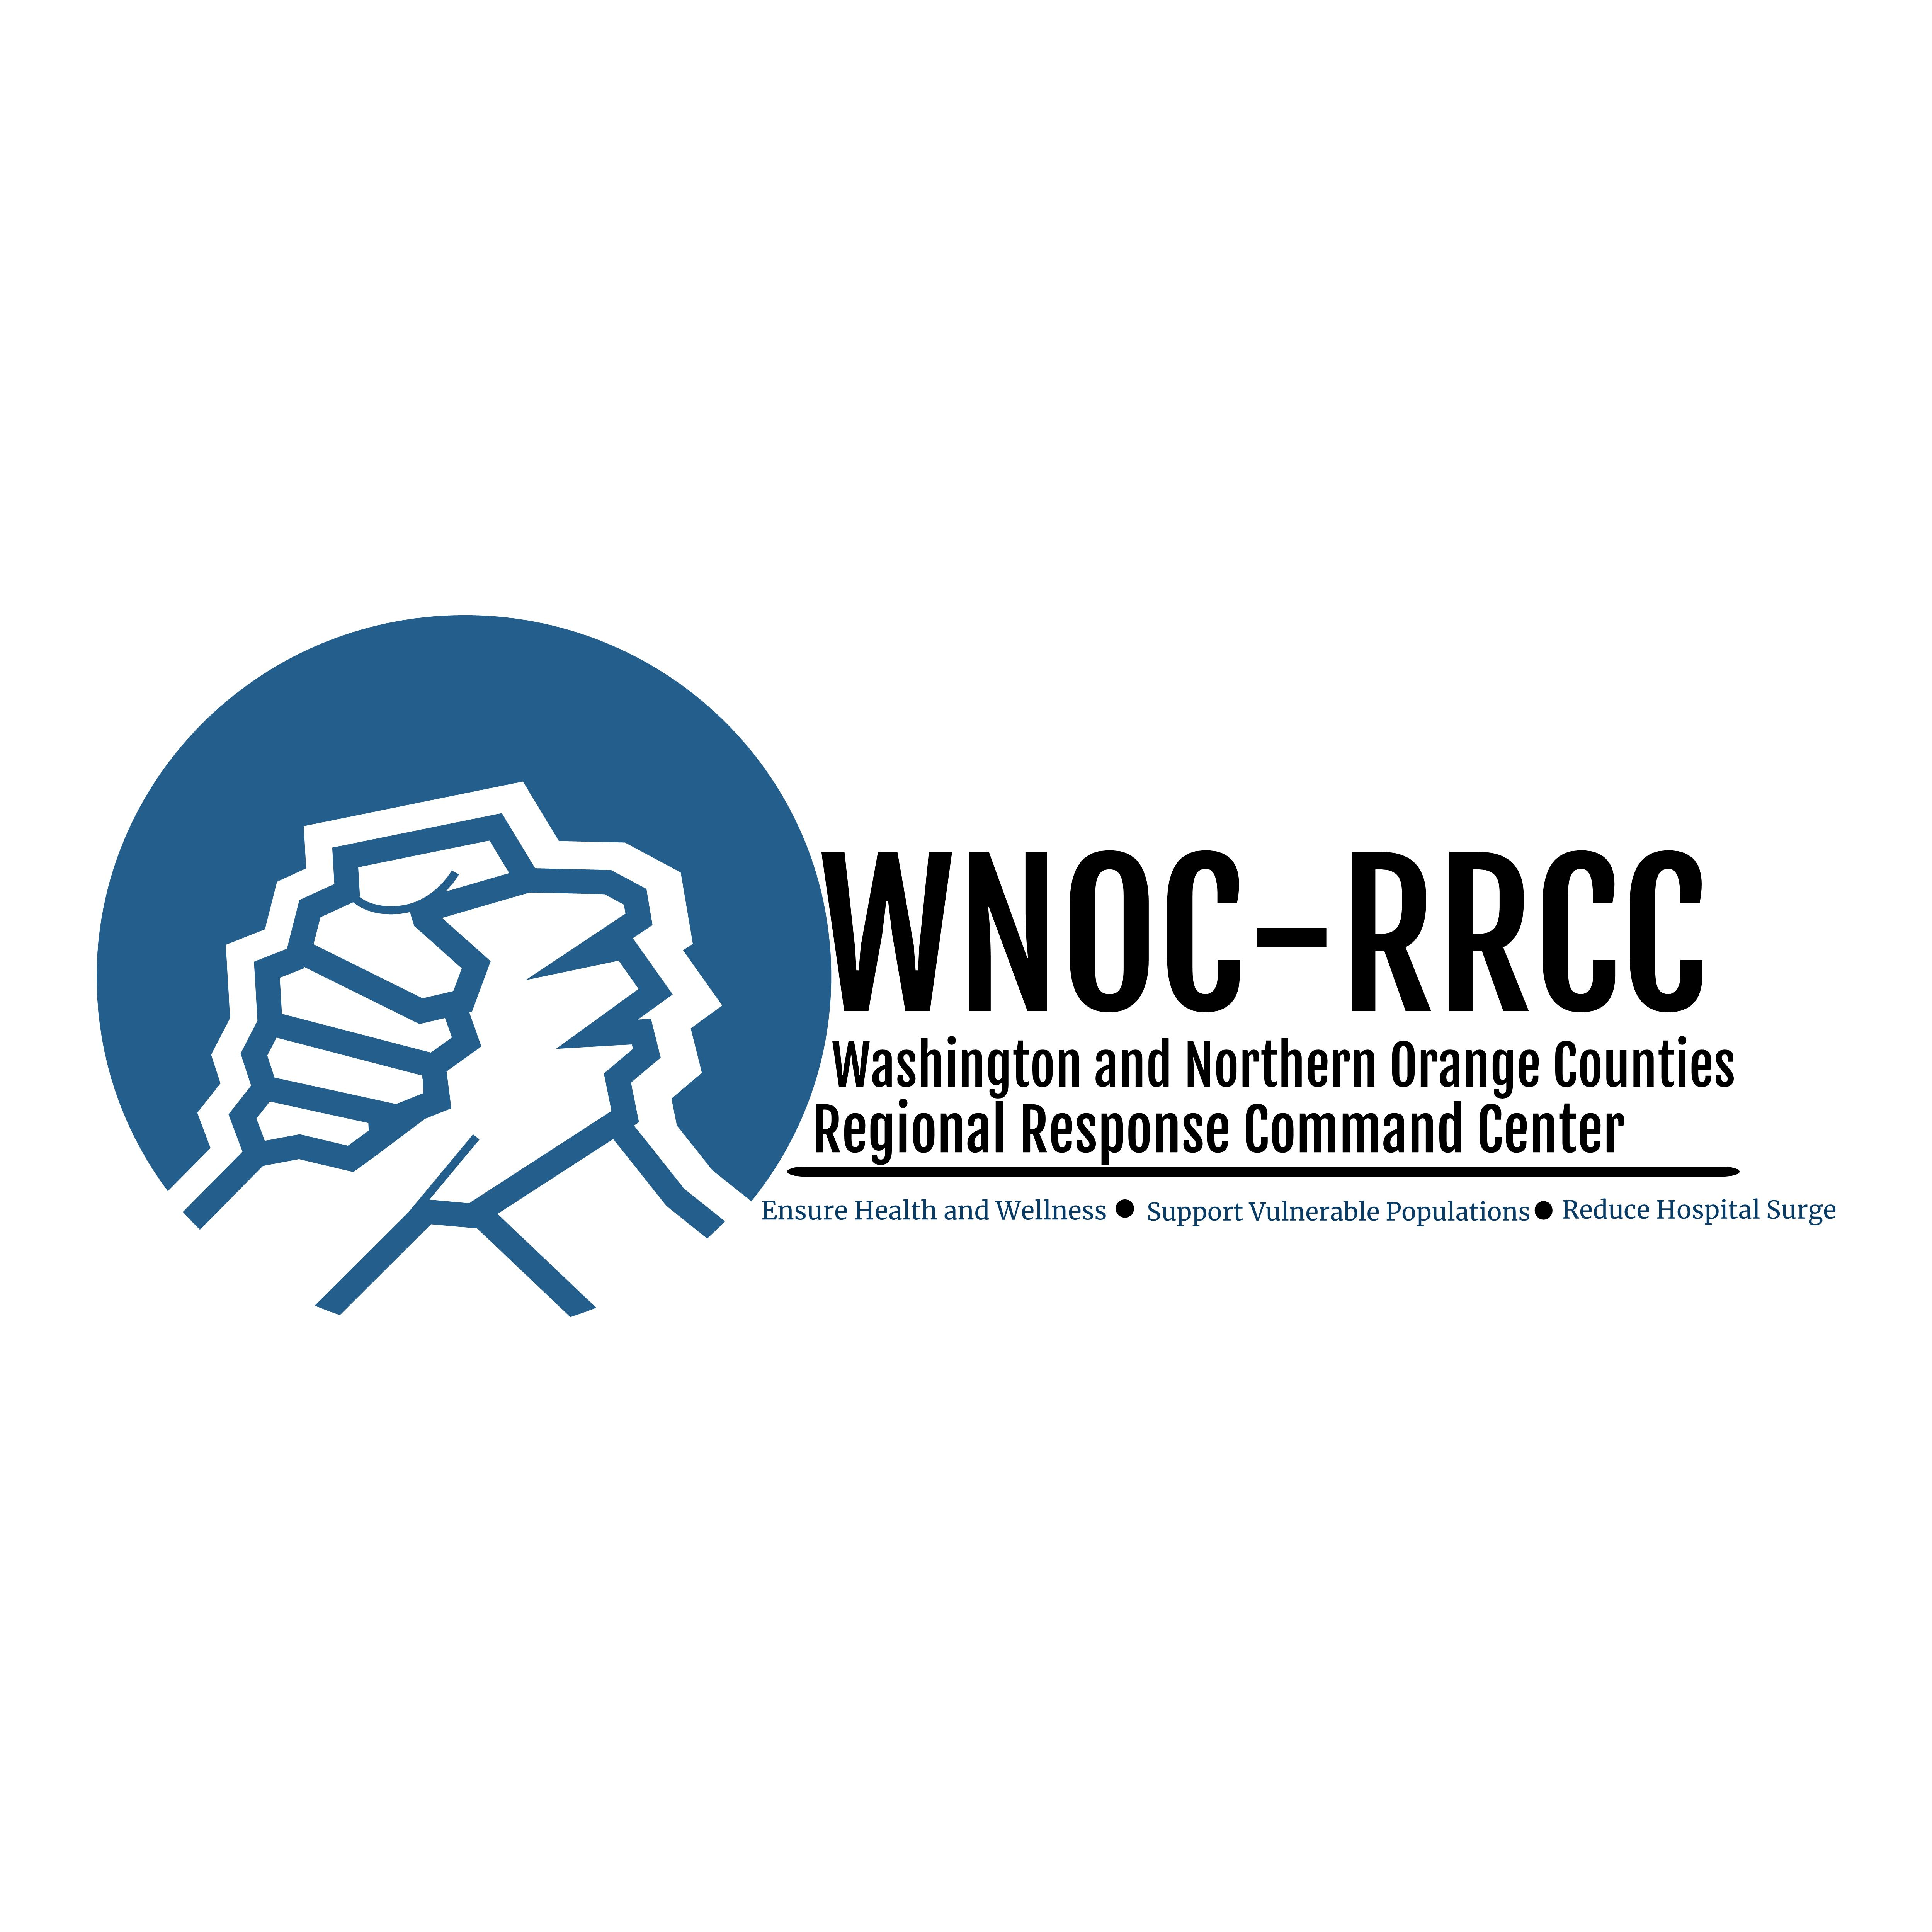

Educational Material and Other Resources

April 8, 2020

Handouts & Posters
- Stop the Spread of Germs (from CDC): basic strategies for preventing the spread of Coronavirus
- Share the Facts about COVID-19 (from CDC): basic information on COVID-19
- WHO Hand Rub (from World Health Organization): recommended steps for disinfecting your hands using hand sanitizer
- WHO Hand Washing with Soap & Water (from World Health Organization): recommended steps for cleaning your hands with soap and water

Videos
- Video on WHO recommended steps for hand rubbing with hand gel (from Johns Hopkins): https://www.youtube.com/watch?v=B3eq5fLzAOo
- Video on WHO recommended steps for hand washing with soap and water (from Johns Hopkins): https://www.youtube.com/watch?v=IisgnbMfKvI
- Video on removing of gloves (from ProTraining): https://www.youtube.com/watch?v=kesQF_G3pQ8
- Video on the right way to put on and take off cloth face coverings (from National Jewish Health): https://www.youtube.com/watch?v=iGE5eny_9gA

Other Resources
- What’s the best material for making cloth face covering – article from The New York Times
- How to sew a cloth face covering – article from The New York Times

