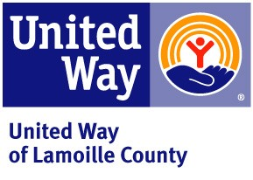
Donor Designation Policy
Approved 6/8/09
3/8/10

The United Way of Lamoille County encourages donors to make unrestricted contributions to the United Way Community Fund. This fund allows the Investment Committee to determine the most critical needs in our community and to allocate the dollars to meet those needs. When considering investments to Community Partners, the Investment Committee will not be provided with designation information. Investments will be made in addition to designations.

Donors may choose to designate their gift directly to an organization of their choice, either to a United Way partner agency, or to a non-partner agency, by indicating their desire on their donor pledge form.

DESIGNATION MINIMUM: Donor designations must be over $100 per agency, to a 501c3 non-profit health or human service organization providing service in the United States, preferably in the state or region. If a designation does not meet these criteria, it will become part of the United Way Community Fund. A good faith effort will be made to distribute donor designated funds to the intended recipient.

Although it is not encouraged, a donor may also choose to make a “negative designation”, instructing United Way NOT to direct dollars to a particular agency. In this case, the dollars will become donor designated in equal increments to the other partner agencies.

PROCESSING FEE: A processing fee of 5% of the total donation will be assessed for each check issued. Gifts to other United Way Community Partners and to other United Ways will be passed through without an administrative deduction, but must meet the minimum $100 per agency.

Designations will be paid out in April of each year, less any uncollectible amounts.

Agencies funded by United Way of Lamoille County may not promote or encourage designations to their agency in any manner, at any time. This restriction applies to any form of written or verbal communication to all audiences, including, but not limited to, volunteers, board members, agency staff, current contributors, service recipients and potential contributors at agency events or at workplace presentations.

Partner agencies will positively promote United Way’s community-wide campaign with all audiences as the best choice to assist a broad range of health and social service needs and will promote the United Way investment process of distributing funds based upon identified community needs.

Violation of the Donor Designation Policy by a partner agency may result in reduced investments or even membership termination from United Way of Lamoille County.

This policy will be reviewed on an annual basis.

Dawn/Policies/Donor Designation Policy

