Good morning,

As of 5/16/24 there are 82 households at risk of becoming homeless and 59 households are literally homeless in Lamoille county. In total, 182 adults and 97 children at risk of or are currently experiencing literal homelessness in Lamoille County.

**Sharing priority**

[LCFS Visitor Survey](https://docs.google.com/forms/d/e/1FAIpQLSfpWxTlFaw2I-qYtjaBl-cdwH0Sjbic7wehTvwZQWVGrPMhAw/viewform): If you have visited the food shelf, please consider taking their visitor survey. The first 200 participants will receive a $25 Shaws gift card!

**Community**

*RESCHEDULED* [Free ﻿Flood Legal Assistance Clinic](https://sblc.vermontlaw.edu/events/flood-clinic-hyde-park-vt/): Lawyers from the Vermont Law School’s Small Business Law Clinic, Vermont Legal Aid, and Legal Services Vermont will be on hand to help businesses that need help accessing legal service regarding the July 2023 flooding damage.

* *5/30, 12-4pm*
* *Green Mountain Technology & Career Center, 738 VT Route 15 W, Hyde Park*
* This month, help is available for recertifying Continued Temporary Housing (Rental) Assistance.
* Questions: [sblc@vermontlaw.edu](mailto:sblc@vermontlaw.edu)

*Cooler Safety Stickers*: Keep your non-alcoholic and alcoholic drinks in separate coolers and label them with easy-to-read stickers.

* Email [jessica@healthylamoillevalley.org](mailto:jessica@healthylamoillevalley.org) to request stickers

*Upcoming Library & art center events:*

* [Johnson Public Library](https://www.johnsonpubliclibrary.org/current-youth-schedule)
* [Wolcott Library](https://www.wolcottvtpubliclibrary.com/events-1)
* [Craftsbury Public Library](https://www.craftsburypubliclibrary.org/calendars?view=calendar&month=05-2024)
* [Stowe Free Library](https://www.stowefreelibrary.org/welcome)
* [Lanpher Memorial Library](https://www.lanpherlibrary.org/librarycommunity-calendar.html)
* [River Arts](https://www.riverartsvt.org/program-calender)
* [Rural Arts Collaborative](https://ruralartsvt.org/events)
* [The Current](https://www.thecurrentnow.org/education)

[Summer EBT](https://summerebt.vermont.gov/):

* If your family already gets benefits like 3SquaresVT, you'll be enrolled in the Summer EBT program.
* If your family isn't automatically in but might be eligible, you will be able to apply online when applications open in August

**Health and Wellness**

[Pathways to Prevention](https://www.eventbrite.com/e/pathways-to-prevention-tickets-901493821287?aff=oddtdtcreator): Free community event on holisitic community-centered practices and the intersection of substance misuse and trauma

* 6/17, 9am-3:30pm
* Vermont State University Lyndon Campus, 1001 College Road Moore Community Room

*Measles information:*

* Measles is a [highly contagious respiratory virus](https://www.cdc.gov/measles/about/index.html) that can cause serious illness. There is no treatment for measles, however, it is almost entirely vaccine preventable.
* Symptoms: cough, runny nose, watery eyes, and high fever (may spike to more than 104°). A rash of flat spots breaks out on the head and face, then spread.
* Check your MMR vaccination status.
  + Confirm with your Primary Care Provider or request your records from the Vermont Immunization Registry ([How to Request)](https://www.healthvermont.gov/sites/default/files/documents/pdf/IMR_Requesting_Vaccine_Records.pdf).
  + If not up to date, call your PCP
    - Morrisville Local Health Office offers routine vaccinations, including MMR for measles, at no cost for those under 65yo and uninsured or experiencing significant barriers to access.
    - Call 802-888-0511 to make appt

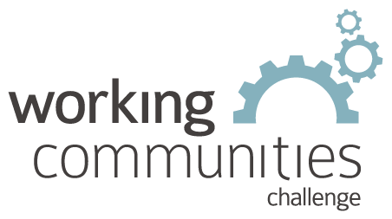 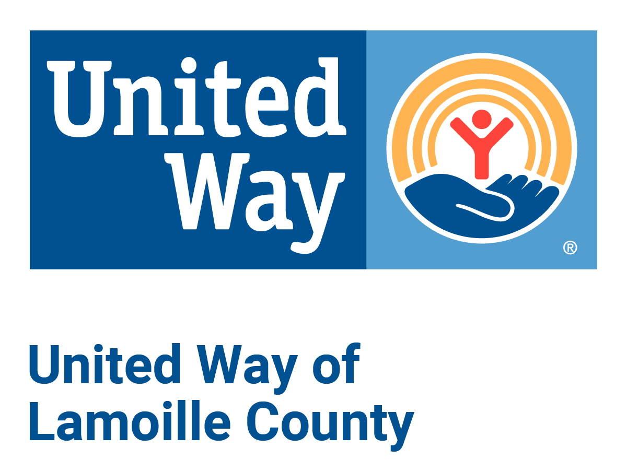

**What is WCC and what is this email?**

WCC stands for Working Communities Challenge, a three-year grant from the Federal Reserve Bank of Boston to support collaborative work to remove systemic barriers to employment. United Way of Lamoille County is the backbone partner in the [Lamoille WCC](https://uwlamoille.org/partnerships/working-communities-challenge.html), with 24 core partners participating.

Knowing what is going on helps people join the economy, so please share the sharing priority and the rest of the information in this newsletter.

* This newsletter goes out weekly to approximately 600 area leaders. The language is often exactly or close to what organizations use in order to convey what they want shared. It may not be in quotation marks for simplicity, but it is the language of the contributing organization.
* The [United Way of Lamoille County resource page](https://uwlamoille.org/get-help/) is continually updated with local and state information.

Elisabeth Ortiz

Working Communities Challenge

United Way of Lamoille County