Good morning,

In our area, there are 89 households (109 adults and 47 children) who are experiencing or at risk of experiencing homelessness. 54 households are experiencing literal homelessness: general assistance program, in a tent, on street, in a vehicle, or in temporary shelter.

This is YOUR newsletter – you can send us any information you want shared with the community.

**Sharing priority**

[Addressing Poverty in Lamoille: An Interfaith Teach In + Fundraiser](https://uwlamoille.org/how-to-help/interfaith-teach-in.html)

* Saturday, June 3rd
* 6-8 PM
* In Person: Blessed Sacrament Church (728 Mountain Road, Stowe)
* [Virtual option](https://uwlamoille.org/how-to-help/interfaith-teach-in.html)

**Community**

*Anxiety therapy group*: Acceptance and Commitment Therapy (ACT) is a proven way to treat anxiety by helping us get out of our heads and into our lives.

* For adults 18+ who experience anxiety as their primary issue or mental health challenge.
* 8-week, in-person-only group
* Mondays at noon (starting June 12) at Lamoille Health Partners, Morrisville,
* 802-888-8320

[*Virtual roundtable conversation* on supporting youth vaping cessation](https://www.healthylamoillevalley.org/youth-vaping-conversation/): talk about local strategies, challenges, and successes related to youth vaping cessation.

* 5/23 3:30-4:30 PM on [Zoom](https://us06web.zoom.us/meeting/register/tZ0rcOisqjkjG9B7HaoeyhoJf7qlgl_Bj_Hx#/registration).
* [Video of February meeting](https://www.healthylamoillevalley.org/supportingyouthnicotinecessation/)

*BBQ, Ribs and Shrimp + Tacos* to raise funds for Heifer Project International and a gift of a Farm animal plus Garden Seeds for a Johnson area resident.

* United Church of Johnson
* 6/3, 3-7 pm.
* Piñata, bingo, yard games

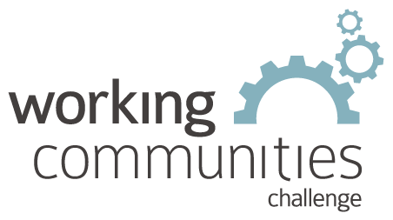 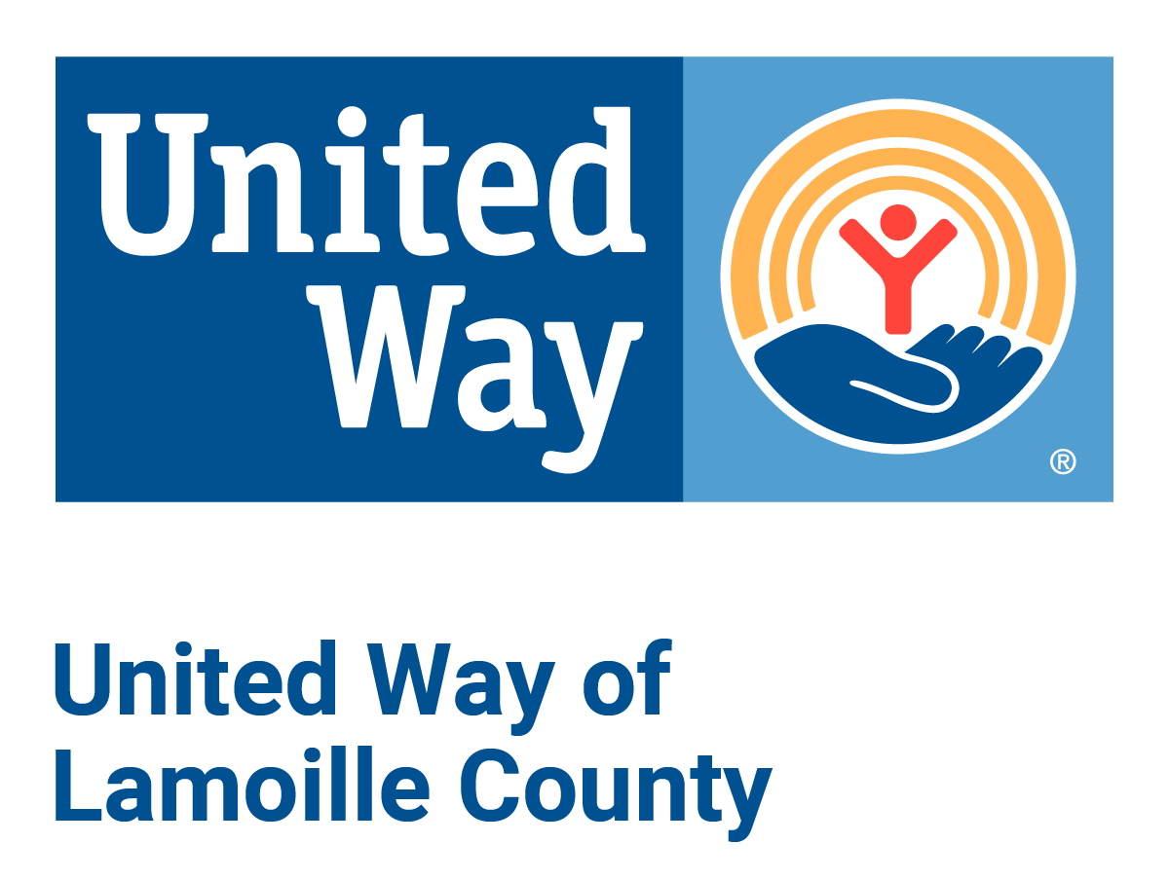

**What is WCC and what is this email?**

WCC stands for Working Communities Challenge, a three-year grant from the Federal Reserve Bank of Boston to support collaborative work to remove systemic barriers to employment. United Way of Lamoille County is the backbone partner in the [Lamoille WCC](https://uwlamoille.org/who-we-are/working-communities-challenge.html), with 24 core partners participating.

Knowing what is going on helps people join the economy, so please share the sharing priority and the rest of the information in this newsletter.

* This newsletter goes out weekly to approximately 600 area leaders. The language is often exactly or close to what organizations use in order to convey what they want shared. It may not be in quotation marks for simplicity, but it is the language of the contributing organization.
* The [United Way of Lamoille County resource page](https://uwlamoille.org/get-help/) is continually updated with local and state information.