| **File with FEMA *and* report damages to** [**vermont211.org**](http://vermont211.org)**. *Denied by FEMA? You can and should appeal.*** | |
| --- | --- |
| *Get help with FEMA at a Disaster Recovery Center (DRC):*   * **Johnson:** McClelland Hall, 131 College Rd * **Barton:** Memorial Building, 17 Village Sq * **Danville**: CLOSED * **Cabot:** Cabot Town Hall, 3084 Main St * **8a -6p Mon - Sat** | *At the DRC:*   * File with FEMA * FEMA appeals * Learn about disaster assistance programs * Find out the status of your FEMA application * Get answers about federal assistance * [Disasterassistance.gov](http://disasterassistance.gov) * Learn how to salvage your damaged photos, artwork, textiles, media, etc (*at Johnson only*) |

Good morning,

There are 97 households (133 adults and 72 children) experiencing or at risk of experiencing homelessness in our community. 58 households are experiencing literal homelessness: general assistance program, in a tent, on street, in a vehicle, or in temporary shelter.

**Sharing priority**

***If you have flood damage, register with FEMA before funding goes away!***

* 9/12 is deadline to register
* Register:
  + In-person: See above info on DRCs
  + Online: [disasterassistance.gov](http://www.disasterassistance.gov/)
  + Phone: 800-621-3362

**Resources**

[VCF Farm Disaster Relief Grant Program](https://vermontcf.org/our-impact/programs-and-funds/farm-disaster-relief/) - $10,000 to 100 farms

* Deadline is 9/27
* Expanded eligibility
* Get help with your application - 802-552-3224, [egearty@vermontcf.org](mailto:egearty@vermontcf.org)

*Hazard Mitigation Helpline:* Help is available to all homeowners, not only those affected by the recent storms.

* 833-336-2487. Listen to prompts, #3 for VT
* FEMA mitigation experts are also available in-person at DRCs (see above).
* LCPC is available to assist with program: 52 Portland St, Morristown, (802) 888-4548

[*FEMA looking for multi-unit buildings to house Vermonters affected by the flood*](https://helpingtohousevt.us7.list-manage.com/track/click?u=dc4c96d2fecf6d05afc8ff3dd&id=bd0ce3e86f&e=d99a6c32ab)

* Properties must be available for term of at least 18mos with the option to extend
* Property must have been previously used as a multi-family housing complex and contain multiple rental units

**Advocacy Opportunities**

[HLV Breakfast and Action Planning: Tobacco/Nicotine/Vape Prevention](https://www.healthylamoillevalley.org/sept-action-planning/): Action planning sessions to prevent and reduce youth substance use and increase the overall health and well-being of our youth.

* 9/12, 9-11am
* GMTCC
* [Register](http://healthylamoillevalley.org/sept-action-planning) by 9/7
* Youth who attend the whole event will receive a $25 gift card

[Pain in the Nation 2023: The Epidemics of Alcohol, Drug, and Suicide Deaths](https://r20.rs6.net/tn.jsp?f=001FpfZZw88-hRz4Hw7gHs66vaK5Qb3ZmU_SHAW8kUnzYdS8qTn7djv2WVbfl2FsA5LclspK1Yv0dGIKjaXbX_cegvP03cgEY2pGWGCUMQIr9mvuVcT2etjPh5hGf8YnrksWnVxjoQO8kpSvUiHwy3FcTefBVrMTebUJ1fmJSUz_pnfpLTCVVni9JaIe5avXKwaVVScIB-Ggdk=&c=Thk1Y8VAbecx9gGd8q6kAZjvyS3sf8pEY6FixzNxzWzkqSaE9ZQuTQ==&ch=7eJ8__i_h-iLCTxyt008wDitksxmv6uBJBq-IXRI2hOZmIolbWjpCw==): national webinar on 11% increase of deaths in 2021 due to alcohol, drugs, and suicide.

* 9/26, 2-3pm
* Discuss steps policymakers should take to begin to reverse these crises

**Support**

*LHP Behavioral Health and Wellness* *Support & Psychoeducation Group for Caregivers of Gender Diverse Youth*

* 6 session
* Sign up with [this form](https://forms.office.com/r/PHj5ZQiZw3)
* Questions: 802-888-8320

*Helpers in Healing: Family & friends discussion group:* help support someone who has experienced pregnancy or infant loss, is pregnant after loss or parenting after loss.

* Each month focuses on a different topic of discussion
* 9/11, 10/9, 11/13
* 12–1pm online
* [Register](https://www.emptyarmsvermont.org/helpers-in-healing)

**Community**

*RCT Johnson Shopper route is back to its regular schedule*

* 1st and 3rd Thursday each month
* starting 9/14
* On-demand flood relief transportation available
* ?’s: 802-748-8170

[14th annual VT Pumpkin Chuckin’ Festival](http://vtpumpkinchuckin.blogspot.com/): Funds raised from this event support the Clarina Howard Nichols Center’s work to end domestic and sexual violence in Lamoille County.

* 10/1, 11am-4pm
* Stowe Events Field, Weeks Hill Road, Stowe
* New! Craft fair - [vendor sign up](https://drive.google.com/file/d/1gnVaBNBHovyB89vnGzPQ8xlaITqtrAcl/view)

[Lamoille Valley Playgroups](https://www.lamoillefamilycenter.org/): 9/11 through May 2024 following public school calendar

* All sessions 9:30-11am
* Mondays, River Arts, 74 Pleasant St, Morrisville
* Thursdays, LFC, 480 Cady's Falls Road, Morrisville
* Fridays, VTSU Johnson SHAPE pool, 238 S Pond Rd, Johnson
* Questions: jstanton@lamoillefamilycenter.org

**Jobs and Training**

[Youth Social Media Intern](https://docs.google.com/document/d/1ou-CNXwoMoIg9MAd-6JLxk1lDbiQLCCsPCACQdtWgyM/edit?usp=drive_web) at Healthy Lamoille Valley: Manage, reshare, and create original content for Instagram.

* 15-18yo
* 5hrs/wk for school year, $13/hr
* Application deadline: 9/8
* Send letter of interest stating qualifications to [brian@healthylamoillevalley.org](mailto:brian@healthylamoillevalley.org)

*Criminal Court Advocate for the Clarina Howard Nichols Center:* Provide advocacy services for survivors of domestic and sexual violence who are involved with the criminal justice system.

* Competitive pay and benefits, health insurance, paid time off, and a flexible schedule.
* Apply: send cover letter and resume to bgonyea@clarina.org or mail to PO Box 517, Morrisville

[Careers In Banking Training](https://cftea.org/product/foundations-in-banking-certificate-bundle/) – beneficial to potential employees as well as those new to the financial industry; a direct path to a career in banking

[LNA training starting October 1st](https://gmtccadulteducation.coursestorm.com/course/licensed-nursing-assistant4)

* GMTCC
* Grant funding possible if qualified - email Harka Khadka, [khadka@vsac.org](mailto:khadka@vsac.org)

VT Coalition of Runaway and Homeless Youth Programs jobs:

* [Assistant Director](https://helpingtohousevt.us7.list-manage.com/track/click?u=dc4c96d2fecf6d05afc8ff3dd&id=67c93022a3&e=d99a6c32ab)
* [Projects Administrator](https://helpingtohousevt.us7.list-manage.com/track/click?u=dc4c96d2fecf6d05afc8ff3dd&id=928c21fa57&e=d99a6c32ab)

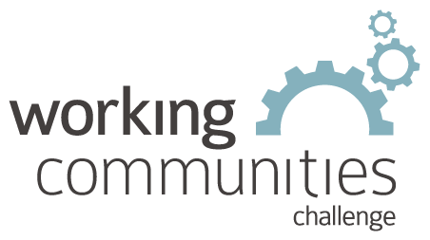 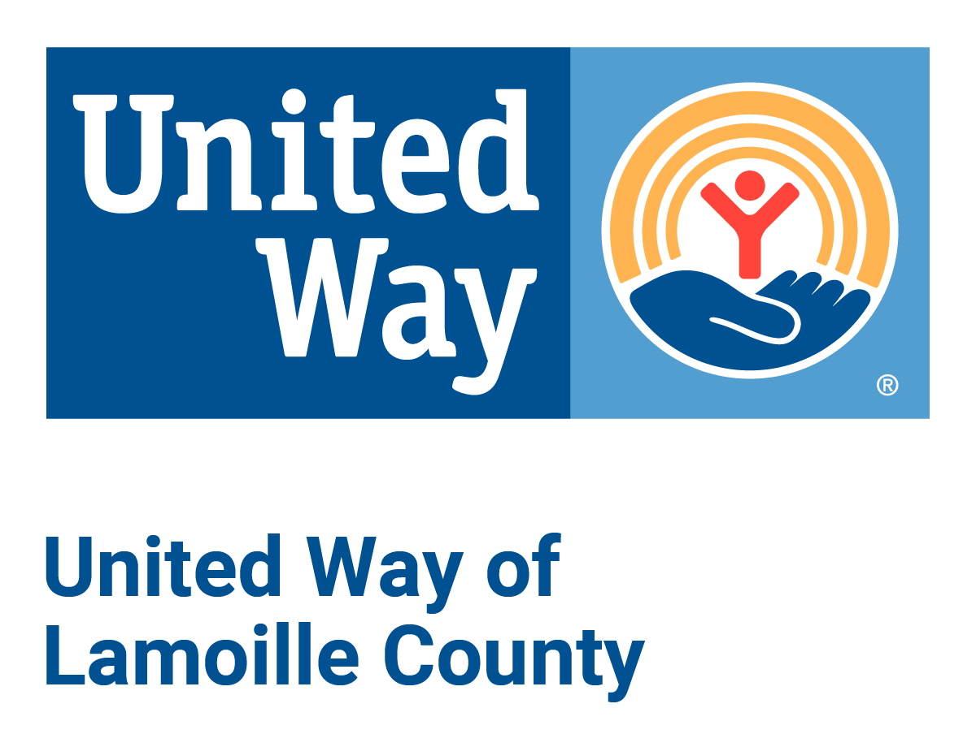

**What is WCC and what is this email?**

WCC stands for Working Communities Challenge, a three-year grant from the Federal Reserve Bank of Boston to support collaborative work to remove systemic barriers to employment. United Way of Lamoille County is the backbone partner in the [Lamoille WCC](https://uwlamoille.org/who-we-are/working-communities-challenge.html), with 24 core partners participating.

Knowing what is going on helps people join the economy, so please share the sharing priority and the rest of the information in this newsletter.

* This newsletter goes out weekly to approximately 600 area leaders. The language is often exactly or close to what organizations use in order to convey what they want shared. It may not be in quotation marks for simplicity, but it is the language of the contributing organization.
* The [United Way of Lamoille County resource page](https://uwlamoille.org/get-help/) is continually updated with local and state information.

Elisabeth Ortiz

Working Communities Challenge

United Way of Lamoille County